Kliiniline küsimus nr 1
Does providing/ not providing information about the nature and course of the forthcoming operation/ surgical procedure affect postoperative pain?

Critical outcomes: pain intensity, pain relief, anxiety rescue mediaction (incl opioid consumption), patient ( caregiver) satisfaction with pain treatment.

Süstemaatilised ülevaated
Kokkuvõte süstemaatilistest ülevaadetest

Johansson et al (2004) identified 11 articles involving 1044 participans. Most studies included one experimental group and one control group. The educational interventions varied widely, but the most common intervention based on written materials alone, or written material combination with ohter teaching methods. The most common outcome measure related to pain, knowledge, anxiety, exercises and lenght to stay. Almost all reported one or more statistically significant effects. Based on the findings of the meta-analysis, preoperative education appears to have some impacts on patient´s anxiety and knowledge levels. Four of the studies were truly RCTs, including randomization to experimental and control groups as well as pre- and post tests before and after surgery.
Daltroy et al (1998). Population and sample size=216. Teaching methods: experimental group (E )and control group, E1 n=52: slide-tape information about hospidal events concerning surgery and postoperative care and relaxation training, E2 n=58: slide-tape information about hospidal events concerning surgery and postoperative care. E3 n=58: relaxation training, C n=54: neither, no future details. Results: Anxiety: (less E1, E2 patients most baseline anxiety), mental status (less cognitive errors in E1, E2 for patients most baseline anxiety). Pain medication use (less E1, E2 for paients most baseline denial).
Lilja et al (1998) Population: total hip replacemet patients n= 50 and breast cancer patients n=4. Teaching methods: Experimental group E THR (n= 22) and E ca (n=22) anaesthetic nurses and ward nurses teaching about pre-, intra and postoperative care. Control group C THR (n=28) and C ca (n=22) only ward nurses routine pre- and postoperative care teaching. Results: anxiety and pain (E THR vs THR C) no statistically significant effects.
Butler et al (1996), Sample size n=80. Teaching methods: experimental group E (n=32). Booklet about biophysical functional, experimential and social information. Control group C (n=48), no booklet, usul care, no futher details. Results: Anxiety: statistically sinificant effect - less anxiety.

McDonald (2008) research objective was to determine whether preoperative education improves postoperative outcomes (anxiety, pain, mobility, lenght of stay and the incidence of deep veid thrombosis) in patients undergoing hip knee or knee replacement surgery. Nine studies involving 782 participants. Results: Three studies involving 301 patients that presented data for preoperative anxiety found preoperative education to be beneficial in reducing anxiety. The WMD for hip and knees combined was -5,64 (95% Cl -7,45 to -3,82) as measured on the scale of 0 to 100. No significant effect on postoperative anxiety was detected either on the day following surgery, or at discharge. None of the five studies reporting postoperative pain detected any difference between the experimental and control groups. Studies also looked at postoperative anxiety at different time periods. Neither showed any significant difference benefit of postoperative education.
For example Clode-Baker (1997) Intervention group n=41 mailed information about the hospidal stay and postoperative recovery consisting of a 20 minute video, booklet and set of life-size plastic model bones approximately 4 weeks before surgery. There were two groups, preadmission versus no preadmission information. Outcome: preoperative anxiety (Hamilton anxiety and Depression Scale 0 to 21). Results: Intervention group: median 6(range 1 to 17). Control group median 8 (range 2 to 21). No significant difference between two groups.
Outcome:postoperative anxiety (Hamilton anxiety and Depression Scale 0 to 21). Results: Intervention group: median 5 (range 1 to 15). Control group median 5 (range 1 to 15). No significant difference between two groups.
Five studies reporting postoperative pain, none of the studies reportingpostoperative pain detected any difference between the groups. The only study for which data could be extracted for this outcome, the WMD was -2,43 (95% Cl -14,41 to 9,55) as measured on a visual analogue scale.
Data on patient satisfication were presented in two studies, using e five point rating scale where on corresponded to „very dissatisfied“ and five to „very satisfied“. No significant differences between the two groups. (WMD 0,19; 95% Cl-0,02 to 0,39)

Louw et al (2013) systematic review is based on 13 studies, two studies included pain education. Two studies reported positive effect on postoperative pain. McDonald et al (2001) study saple consist 31 patient (18 in control group and 13 communication group). Teaching methods: Power-point slide show to each Basic pain management and pain communication skills. Main results: experimental group reporter less paini n all intervals postoperatively compared to the control group. And another study Gammon et al (1996) found that experimental group used less i/m analgesia. Preoperative education has little effect on postoperative pain in patients undergoing orthopedic patients.

Gurusamy et al. (2014) A total of 431 participans undergoing elective laparoscopy cholecystectomy were randomized. To formal patient education (215 participans) versus standard care (216 participans) in four trials. Patient education methods: verbal education, multimeedia DVD programme, computer-based multimeedia programme, and Power-Point presentation in the four trials.
There were insuffient details to calculate the mean difference and 95%Cl for the difference in pain scores at 9to 24 hours. (1 trial; 93 patients); and studies did not identify clear evidence of an effect on patient knowledge (3 trials, 338 patients, SMD 0,19; 95% Cl-0,02to0,41; very low quality evidence.) Patient satisfication (2 trials, 305 patients, SMD 0,48; 95% Cl-0,42to 1,37; very low quality evidence), patient anxiety (1 trials, 76 patients, SMD -0,37; 95% Cl-0,82 to 0,09; very low quality evidence)between the two groups.
Futher well-designed randomised clinical trials of low risk of bias are necessary.
discharge and following treatment

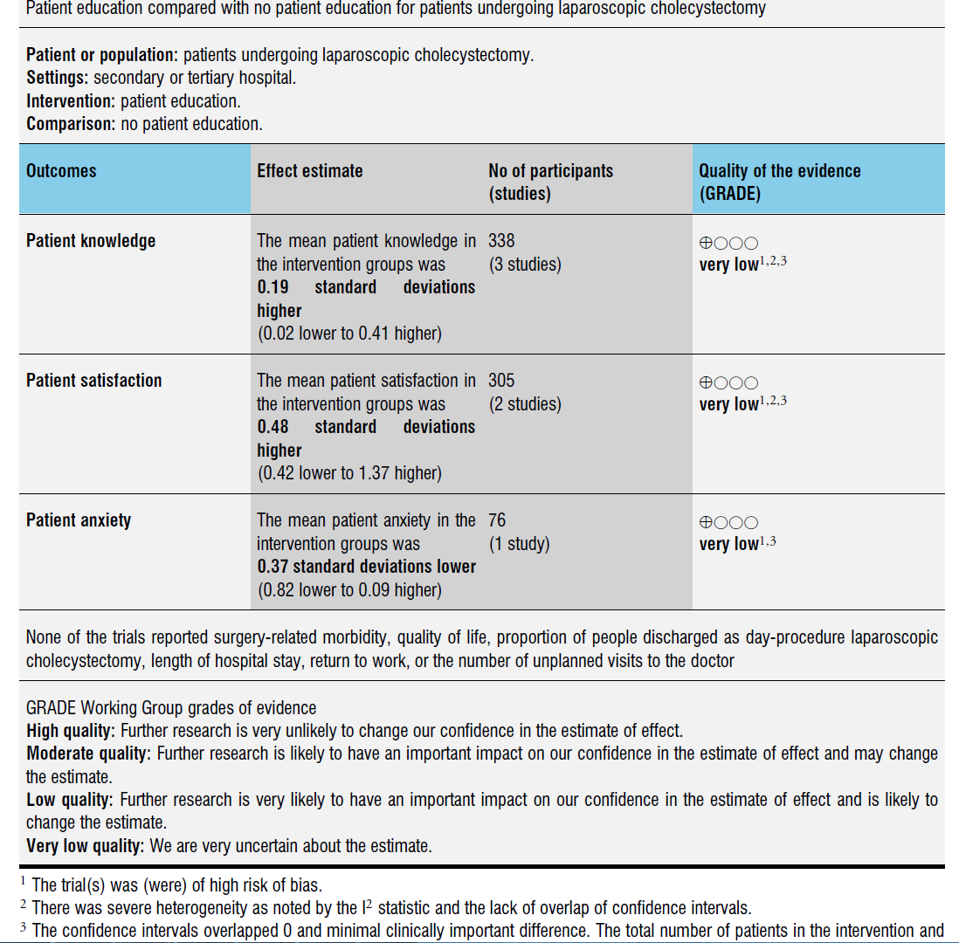

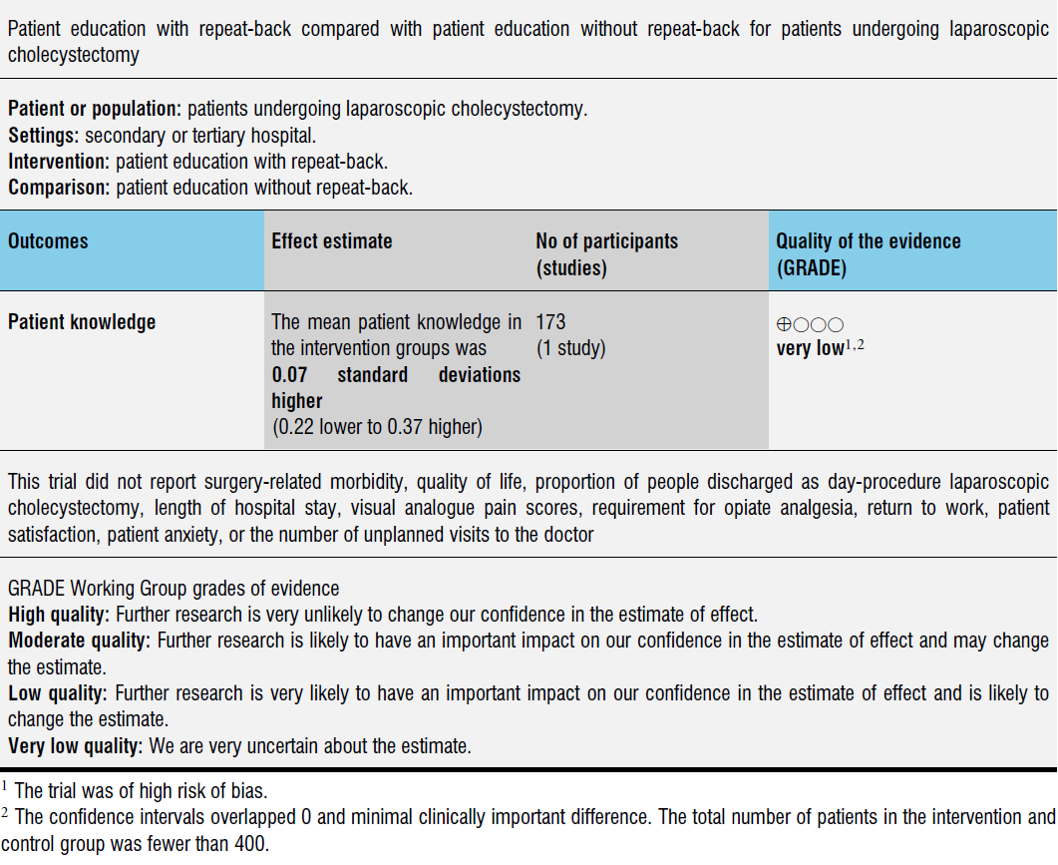

Viited

Kokkuvõtte (abstract või kokkuvõtlikum info) | Viide kirjandusallikale
PURPOSE:  To determine whether preoperative education improves postoperative outcomes (anxiety, pain,mobility, length of stay and the incidence of deep vein thrombosis) in patients undergoing hip or knee replacement surgery.  DATA SOURCES: MEDLINE (1966 to April 2003), EMBASE (1980 to June 2002), CINAHL, PsycINFO and PEDro until May 2003. We handsearched the Australian Journal of Physiotherapy (1954 to 2001) and reviewed the reference lists.  STUDY SELECTION: Randomised trials of preoperative education (verbal, written or audiovisual) delivered by a health professional within six weeks of surgery to patients undergoing hip or knee replacement.  DATA COLLECTION AND ANALYSIS: Two reviewers independently assessed study quality and extracted data. Continuous outcomes were combined using weighted mean difference (WMD) and 95% confidence intervals (CI).  MAIN RESULTS: Nine studies involving 782 participants met the inclusion criteria. Four studies involving 365 participants assessed length of hospital stay (days) but detected no significant difference between preoperative education and usual care (WMD ‐0.97; 95% CI ‐2.67 to 0.73). However, one study of 133 participants with more complex needs, indicated that individually tailored programmes of education and support were beneficial in reducing length of stay. The four studies reporting length of stay did not find any significant effect of preoperative education on days to standing and days to climb stairs. Three trials found preoperative education was beneficial in reducing preoperative anxiety (WMD ‐5.64; ‐7.45 to ‐3.82) on a scale of 0 to 100. No significant effect on postoperative anxiety was detected either on the day following surgery , or at discharge. None of the five studies reporting postoperative pain detected any difference between the groups.  AUTHORS` CONCLUSIONS: There is little evidence to support the use of pre‐operative education over and above standard care to improve postoperative outcomes in patients undergoing hip or knee replacement surgery, especially with respect to pain, functioning and length of hospital stay. There is evidence that preoperative education has a modest beneficial effect on preoperative anxiety. There may also be beneficial effects when preoperative education is tailored according to anxiety, or targeted at those most in need of support (e.g. those who are particularly disabled, or have limited social support structures). | McDonald, S.,Hetrick, SE,.Green,S.  Pre-operative education for hip or knee replacement (Review)  Cochrane Database of systematic Reviews 2008
Generally, before being operated on, patients will be given informal information by the healthcare providers involved in the care of the patients (doctors, nurses, ward clerks, or healthcare assistants). This information can also be provided formally in different formats including written information, formal lectures, or audio-visual recorded information.  OBJECTIVES  To compare the benefits and harms of formal preoperative patient education for patients undergoing laparoscopic cholecystectomy.  SEARCH METHODS:  Cochrane Central Register of Controlled Trials (CENTRAL) (Issue 2, 2013), MEDLINE, EMBASE, and Science Citation Index Expanded to March 2013.  Selection criteria: Randomised clinical trials irrespective of language and publication status.  DATA COLLECTION AND ANALYSIS:  Two review authors independently extracted the data. We planned to calculate the risk ratio with 95% confidence intervals (CI) for dichotomous outcomes, and mean difference (MD) or standardised mean difference (SMD) with 95% CI for continuous outcomes based on intention-to-treat analyses when data were available.  MAIN RESULTS:  A total of 431 participants undergoing elective laparoscopic cholecystectomy were randomised to formal patient education (215 participants) versus standard care (216 participants) in four trials. The patient education included verbal education, multimedia DVD programme, computer-based multimedia programme, and PowerPoint presentation in the four trials. All the trials were of high risk of bias. One trial including 212 patients reported mortality. There was no mortality in either group in this trial. None of the trials reported surgery-related morbidity, quality of life, proportion of patients discharged as day-procedure laparoscopic cholecystectomy, the length of hospital stay, return to work, or the number of unplanned visits to the doctor. There were insufficient details to calculate the mean difference and 95% CI for the difference in pain scores at 9 to 24 hours (1 trial; 93 patients); and we did not identify clear evidence of an effect on patient knowledge (3 trials; 338 participants; SMD 0.19; 95% CI -0.02 to 0.41; very low quality evidence), patient satisfaction (2 trials; 305 patients; SMD 0.48; 95% CI -0.42 to 1.37; very low quality evidence), or patient anxiety (1 trial; 76 participants; SMD -0.37; 95% CI -0.82 to 0.09; very low quality evidence) between the two groups.  AUTHORS' CONCLUSIONS:  Due to the very low quality of the current evidence, the effects of formal patient education provided in addition to the standard information provided by doctors to patients compared with standard care remain uncertain. Further well-designed randomised clinical trials of low risk of bias are necessary. | Gurusamy S.K; Vaughan J; Davidson B  Formal education of patients about to undergo laparoscopic cholecystectomy  Cochrane Database of Systematic Reviews  Vol 29; 2014
AIMS:  This paper presents a systematic review whose aim was to describe the scope and methods of the current literature on preoperative patient education and to identify the effects of this education. Background. Preoperative patient education is a common and important inter- vention in surgical nursing, yet there is very limited systematic evidence on its precise role. METHODS:  The Medline, CINAHL, Eric, Psycinfo and Social Sciences Index databases and the Cochrane Library were searched, covering the period from the beginning of each database to April 2003. Studies were included if they concerned adult orthopaedic patients, preoperative nursing patient education and were based on randomized controlled or clinical trials. Meta-analysis was carried out where appropriate.  RESULTS:  We identified 11 articles involving 1044 participants. Most studies inclu- ded one experimental and one control group; only two had more than one experi- mental and control group. The educational interventions varied widely, but the majority were based on written materials alone, or written materials in combination with other teaching methods. The most common outcome measures related to pain, knowledge, anxiety, exercises and length of stay, and the least common to self- efficacy and empowerment. The methodological quality of the studies varied. Almost all reported one or more statistically significant effects. Based on the findings of the meta-analysis, preoperative education appears to have some impacts on patients’ anxiety and knowledge levels.  CONCLUSIONS:  The review clearly highlights the need for well-designed, methodo- logically sound research into the outcomes of patient education. It also points to the need to study patient education from the point of view of empowerment. | Johansson K., Nuutila L, Virtanen H, Katajisto J & Salantera S.  (2005) Journal of Advanced Nursing 50(2), 212–223 Preoperative education for orthopaedic patients: systematic review
OBJECTIVE:  Evaluate content and educational delivery methods of preoperative education in total joint arthroplasties of the hip and knee (THA and TKA) addressing postoperative pain.  DATA SOURCES:  Systematic searches conducted on Biomed Central, BMJ.com, CINAHL, the Cochrane Library, NLM Central Gateway, OVID, ProQuest (Digital Dissertations), PsycInfo, PubMed/Medline, ScienceDirect, and Web of Science. Secondary searching (pearling) was undertaken. DatA EXTRACTION: Data were extracted utilizing the participants, interventions, comparisons, and outcomes approach.  STUDY SELECTION:  All randomized controlled trials (RCTs) evaluating the effect of preoperative education on postoperative pain in THA and TKA surgery were considered for inclusion.  LIMITATIONS:  Studies published in English; published within the last 20 years and patients over the age of 18. No limitations were set on specific outcome measures of pain.  DATA SYNTHESIS:  This review included 13 RCTs involving a total of 1,017 subjects who underwent THA or TKA. Educational delivery methods comprised verbal one-on-one or group education sessions, delivered within 4 weeks of surgery lasting an average of 30 minutes, and accompanied by other written materials. The educational content centered on descriptions of preoperative preparation, hospital stay, surgical procedure, immediate/intermediate experiences, expectations following surgery, rehabilitation, encouragement/reassurance, and answering common question associated with the surgical experience.  CONCLUSIONS:  Preoperative education centered on a biomedical model of anatomy and pathoanatomy as well as procedural information has limited effect in reducing postoperative pain after THA and TKA surgeries. Preoperative educational sessions that aim to increase patient knowledge of pain science may be more effective in managing postoperative pain. | Louw A; Diener I et al  Preoperative education addressing postoperative pain in total joint arthroplasty: Review of content and educational delivery methods  Physiotherapy Theory and Practice ; 29(3):175-194, 2013

Ravijuhendid

Kokkuvõte ravijuhendites leiduvast
Guidelines what we used:
Acute Pain Management: Scientific Evidence 2010 (AU-10).
Guidelines on Pain Management 2013 (URO-13).
“ Behandlung acuter perioperativer und postraumatischer Schmertzen” 2009 (Schmertzen) (DE-07).

All guidelines coincide:
All patients must be informed preoperatively about postoperative pain (AU-10, URO-13, DE-07).

Preoperative information about forthcoming procedure is effective, improves postoperative recovery, reduces pain and the use of analgesics and length of hospital stay. Careful pain assessment by the surgeon or the acute pain team before and after treatment can lead to more efficient pain control (AU-10, URO-13, DE-07)

Preoperative education improves patient or carer knowledge of pain and engourages a more positive attitude towards pain relief (AU-10, URO-13, DE-07).

All patients must be instructed how to evaluate pain intensity by themselves, it improves pain assessment, pain treatment, reduces complications and shortens hospital stay (AU-10, URO-13, DE-07)

Some studies have shown no effect of education on postoperative pain or analgesic requirements, although there may be an increase in patient satisfaction and less preoperative anxiety (AU-10)

During information sharing process is not allowed to suggest unrealistic expectations and fear (DE-07).

In some patients, especially those with an avoidant coping style, giving too much information or asking them to make too many decisions may exacerbate anxiety and pain. However, later evidence suggested that this may not be a strong effect (AU-10).

Children, adolescents and pateints with cognitive disorders must be informed in the presence of a caregiver (DE-07).

