Kliiniline küsimus nr 9
Kas bariaatrilise kirurgia patsiendi kasutada RY vs SG vs AB ravi-tulemuseks operatsioonimeetoditega saavutatavad ravitulemused?

Tulemusnäitajad: Operatsiooni kestvus, ravikulu vähenemine (5 aasta perspektiiv), hilisemate kirurgiliste ja mittekirurgiliste tüsistuste esinemissagedus, kvaliteetselt elatud eluaastate lisandumine (QALY).

Hetkel pole piisavalt tõendusmaterjali üldistamaks ühe konkreetse bariaatrilise kirurgilise protseduuri kasuks (USA ravijuhend, 2013).

USA kohortuuring:
Operatsioonitüüp | Lühend | Kestvus minutites
lap.bypass | RY (n=2966) | 53 minutit
band | AB (n=352) | 35 minutit
sleeve | SG ( n=118) | 46 minutit
kordusoperatsioon | RP (n=67) | 71 minutit

73% (n=49) RP oli primaarne protseduur AB, 24% (n=16) RY ja 3 % (n=2) SG.¹
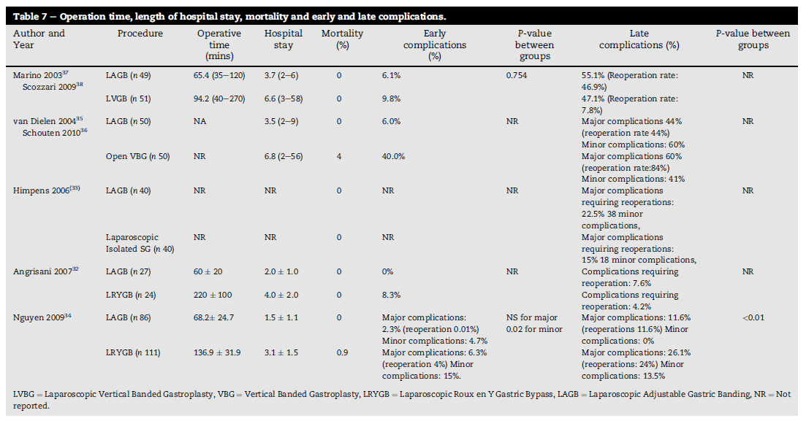
Vanemates uuringutes operatsiooniajad pikemad, näiteks LGBP vs band (RCT, Angrisani 2007) keskmine op kestvus 220 min vs 60 min³.
Joonis 1 Chakravarty et al. 2012

Ravikulu vähenemine 5 aasta perspektiivis
Postoperatiivsed tüsistused kokku (USA kohortuuring, varane/hiline diskrimineerimata):
AB (2,84%) < RY (6,91%) < SG (12,71%).
Suremus 0,09%; leke 0,51%; veritsus 2,37%; pneumoonia 0,63%; VTE 0,40%; reoperatsioon 2,34%.
Surmajuhtumeid esines vaid RY. Leket esines enim SG. Veritsust esines enim RY. Pneumooniat ja VTE esines enim SG. Reoperatsioone esines enim SG. ¹

Postoperatiivsed tüsistused (varased, <30 päeva, USA kohortuuring):
AB (2,4%) < SG (6,3%) < RY (10,0%);
Suremus kõikidel protseduuridel statistilise erinevuseta.²

Hilisemate kirurgiliste ja mittekirurgiliste tüsistuste esinemissagedus (Cochrane ülevaade)³
LGBP vs band (Angrisani 2007) – bandi grupis reoperatsioon 15,2%, LGBP grupis reoperatsioon 12,5%; varased kirurgilist ravi vajavaid komplikatsioone LGBP grupis 8,4%.
Sleeve vs band (Himpens 2006) – sleeve 2/32 varase kordusoperatsiooni vajadus; bandi grupis varase kordusoperatsiooni vajadus 0/34; hilise kordusoperatsioonivajadus bandi grupis 7/34, sleeve grupis hilise kordusoperatsioonivajadus 0/32. Bandi grupis komplikatsioone rohkem, statistilist analüüsi samas pole.
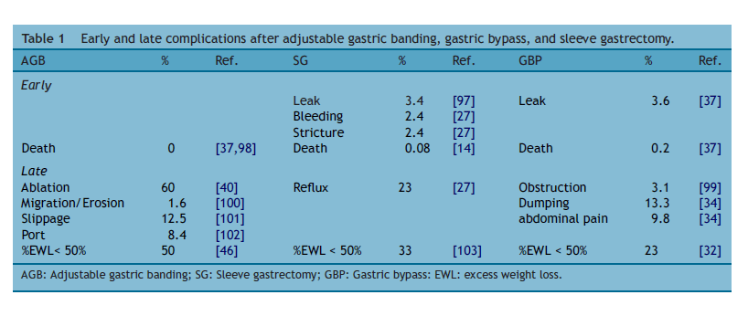

Joonis 2 Gaiazzo R, Pattou F (2013)
QALY lisandumine
HALex on geneeriline tööriist QALY arvutamiseks.
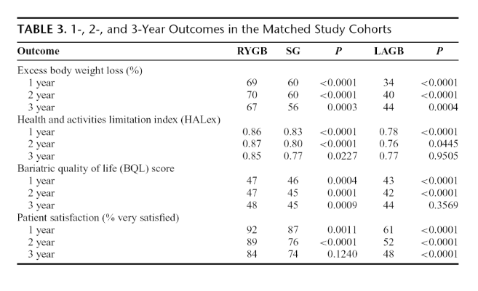
Joonis 3 Carlin et al. (2013)
Ravijuhend | Ravijuhendis sisalduv tekst küsimuse kohta | Viited | Ravijuhendis hõlmatud kirjanduse otsingu ajavahemik
Clinical Practice Guidelines for the Perioperative Nutritional, Metabolic, and Nonsurgical Support of the Bariatric Surgery Patient—2013 Update: Cosponsored by American Association of Clinical Endocrinologists, The Obesity Society, and American Society for Metabolic & Bariatric Surgery. 2013 | At this time, there is still insufficient evidence to generalize in favor of one  bariatric surgical procedure for the severely obese population (Grade D). In general, laparoscopic bariatric procedures are  preferred over open bariatric procedures due to lower early postoperative  morbidity and mortality (Grade B; BEL 2). |  | 2008-2012

Autor/Aasta/ Uuringumeetod/ TK kvaliteedi hinnang | Uuringu kestvus | Patsientide arv | Ravimeetodid | Peamised tulemused
Chakravarty/ 2012/ süstemaatiline ülevaade/ TK-kõrge | Otsing 1988 - 2011 | 5 RCT | LAGB vs teised kirurgilised meetodid | Co-morbidities and QoL are poorly reported and showed no difference between  LAGB and other bariatric procedures. Evidence suggests that LAGB is not the most effective  surgical procedure to reduce weight. LAGB is associated with lower early complications and  shorter operative time and length of stay, and therefore may be preferable to patients.
Rayford/ 2014/ kohortuuring/ TK-mõõdukas | 2004-2013 | 3460 | LAGB, band, sleeve | Mean operative times decreased to the following: RY, 53 minutes; AB, 35 minutes; SG, 46 minutes; and RP, 71 minutes. Mean length of stay was reduced to the following: RY, 1.53 days; AB, 0.97 days; SG, 2.12 days; and RP, 2.68 days. Major complications were mortality, 0.09%; leak, 0.51%; bleed, 2.37%; pneumonia, 0.63%; venous thromboembolism, 0.40%; and reoperation, 2.34%. The complication rate was lowest for AB and highest for SG (p < 0.05). Adjustable band was the initial procedure in 73% of cases requiring RP. Follow-up compliance was 93% at 1 year, 79% at 3 years, 71% at 5 years, and 33% at 9 years. Adjustable band offered significant weight loss at 1 and 3 years (p < 0.0001), but less than RY or SG (p < 0.0001). Excess weight loss was not significantly different between RY and SG at 1 year. Significant weight loss with RY persisted at 7 to 9 years (p < 0.0001).
Carlin/ 2013/ kohortuuring/ TK- mõõdukas | 2006-2012 | 8847 | LAGB, band, sleeve | Overall complication rates (Fig. 1) among patients undergoing  SG (6.3%) were significantly lower than for RYGB (10.0%, P <  0.0001), but higher than for LAGB (2.4%, P < 0.0001). Serious  complication rates were similar for SG (2.4%) and RYGB (2.5%,  P = 0.736), but higher than for LAGB (1.0%, P < 0.0001). There  were no significant differences in rates of death between the matched  study groups. With regard to specific complications (Table 2), only  leak/perforation (0.85 SG vs. 0.58 RYGB, P = 0.215) and VTE  (0.47 SG vs. 0.34 RYGB, P = 0.413) were higher for SG than for  RYGB. Length of stay and rates of reoperation, readmission, transfer  to another medical facility, and emergency department visits were  similar or slightly higher for patients undergoing RYGBthan for those  undergoing SG and were lower among patients undergoing LAGB.
Gaiazzo/ 2014/ ülevaateartikkel/ TK-nõrk |  |  | LAGB, band, sleeve | Today, no single technique can pretend to be better than  another and each has its own particular balance of benefits and risks (Table 3). AGB, the least aggressive procedure,  has many advocates. SG is undergoing a major expansion because this procedure is associated with rapid and sustainable weight loss. SG is easier to perform than GBP and seems  to be associated with less long-term vitamin deficiency.

1) A Bariatric Surgery Center of Excellence: Operative Trends and Long-Term Outcomes. Rayford et al. Journal of American College of Sugeons, 2014
2) The Comparative Effectiveness of Sleeve Gastrectomy, Gastric Bypass, and Adjustable Gastric Banding Procedures for the Treatment of Morbid Obesity. Carlin et al. Annals of Surgery, 2013.

3) Surgery for obesity (Cochrane review). Colquitt et al. The Cochrane Library, 2009.

4) Adjustable gastric banding, sleeve gastrectomy or gastric bypass. Can evidence-based medicine help us to choose? Gaiazzo et al. Journal of Visceral Surgery,2014.

5) Comparison of laparoscopic adjustable gastric banding (LAGB) with other bariatric procedures; a systematic review of the randomised controlled trials. Chakravarty et al.The Surgeon, 2012.

