**Kliiniline küsimus nr 5**

**Kas kõigil kroonilise neeruhaiguse riskigrupi või kroonilise neeruhaigusega patsientidel kasutada glomerulaarfiltratsiooni täpsemaks määramiseks arvutusliku filtratsiooni kiiruse (eGFR) määramist vs muid meetodeid (kreatiniini kliirensi määramist, tsüstatiin C määramist)?**

Kriitilised tulemusnäitajad:uuringumeetodi tundlikkus ja spetsiifilisus, positiivne ja negatiivne ennustav väärtus, diagnostiline täpsus, kulutõhusus

**Ravijuhendid**

Kokku hindasime 5 ravijuhendit (NICE 2014, KDIGO-CKD 2012, KHA-CARI 2013, SIGN 2008, Mal CKD 2011). Kõigis viies ravijuhendis käsitletakse glomerulaarfiltratsiooni määramist, kuid seda pigem kroonilise neeruhaiguse (KNH) klassifikatsiooni silmas pidades. Erinevaid neerufunktsiooni määramise meetodeid on võrreldud ja laiemalt analüüsitud kolmes ravijuhendis (NICE 2014, KDIGO 2012, SIGN 2008).

Glomerulaarfiltratsiooni määramiseks soovitatakse kõigis viies ravijuhendis (NICE 2014, KDIGO-CKD 2012, CARI 2013, SIGN 2008, Mal CKD 2011) kreatiniini ja kreatiniinil põhineva arvutusliku filtratsiooni kiiruse (eGFR) määramist, kuna vaid kreatiniini määramisel jääb meetodi tundlikkus liialt madalaks. Arvutusliku filtratsiooni kiiruse tulemuste interpreteerimisel tuleb aga arvestada, et mida suurem on glomerulaarfiltratsiooni kiirus, seda ebatäpsem on eGFR-i tulemus.

Soovituslik on eGFR leida 2009a. CKD-EPI kreatiniinil põhineva valemi järgi. Võrreldes varasemalt laialdaselt kasutusel olnud MDRD valemiga ei erine CKD-EPI 2009a. valem tundlikkuse ja spetsiifilisuse osas, kuid omab väiksemat nihet (*bias*) ja on täpsem juhtudel, kui glomerulaarfiltratsiooni kiirus on ≥60 ml/min. Samuti on CKD-EPI valemid (nii kreatiniinil kui ka tsüstatiin C-l põhinevad valemid ja komibeeritud valem) täpsemad eakate patsientide (üle 75 a.) GFR-i hindamisel. (NICE, KDIGO)

Uue neerufunktsiooni hindava markerina tuuakse ravijuhistes välja tsüstatiin C, mis erinevalt kreatiniinist ei sõltu pikkusest, kehakaalust, soost ega vanusest ning dieedist. Diagnostilise täpsuse parandamiseks kasutatakse korraga nii kreatiniinil kui tsüstatiin C-l põhinevat eGFR-i määramist. Täpseima valemina tuuakse välja 2012a. CKD-EPI kombineeritud valem, kus kasutatakse korraga nii kreatiniini kui ka tsüstatiin C väärtust. (SIGN, NICE)

Tsüstatiin C määramist ei ole aga vaja rakendada kõigile uuritavatele, vaid diagnostilise täpsuse parandamiseks olukorras, kus eGFRcreat jääb vahemikku 45-59 ml/min/1.73m2 ja puuduvad muud neerukahjustusele viitavad markerid (n. albuminuuria). Siis tuleks kasutada arvutusliku filtratsiooni kiiruse määramiseks tsüstatiin C-l (eGFRcys) või kombineeritult tsüstatiin C-l ja kreatiniinil (eGFRcreat-cys) põhinevaid valemeid (vastavalt 2012 CKD-EPI tsüstatiin C ja 2012 CKD-EPI kreatiniin-tsüstatiin C). Kroonilise neeruhaiguse diagnoos kinnitub, kui eGFRcys/eGFRcreat-cys on <60 ml/min/1.73m2. (NICE, KDIGO)

Olukordades, kus eGFRcreat-i diagnostiline täpsus võib osutuda ebapiisavaks (neerudoonorite hindamine, toksiliste ravimite doseerimine vastavalt neerufunktsioonile) on soovitatav glomerulaarfiltratsiooni kiiruse hindamiseks kasutada lisameetodit. Kuldstandardiks on sellistel juhtudel kliirensi mõõtmine kasutades eksogeenset filtratsioonimarkerit (inuliin, 51Cr-EDTA, 125I-iothalamate, iohexol). See meetod on aga tehniliselt keeruline, kallis ja aeganõudev, mistõttu käepärasema ja odavama alternatiivina soovitatakse määrata eGFRcys/eGFRcreat-cys. (SIGN, NICE, KDIGO)

Kreatiniini kliirensi määramine jääb oma diagnostilise täpsuse poolest eGFR-ile alla ja seetõttu kreatiniini kliirensi määramist 24h uriini alusel ravijuhendid ei soovita. (SIGN, NICE, KDIGO)

NICE´i ravijuhendis on teostatud ka kulutõhususe analüüs. Selle alusel ei ole CKD-EPIcreat kasutamine kallim kui MDRD valemi kasutamine. Kroonilise neeruhaiguse diagnoosi täpsustamiseks patsientidel, kelle eGFRcreat on 45-59 ml/min/1.73m2 ja kellel samas puuduvad teised neerukahjustusele viitavad markerid, on kõige kulutõhusam täiendavalt määrata eGFRcys.

**Scottish Intercollegiate Guidelines Network. Diagnosis and management of chronic kidney disease. A national clinical guideline. 2008**

Arvestades antud ravijuhendi avaldamise aega, on siin võrreldud vanemaid eGFR-i arvutamise valemeid (Cockcroft-Gault vs. MDRD). Tõendus põhineb kõrge kvaliteediga süstemaatilistel ülevaadetel. Kokkuvõttes kinnitab antud ravijuhend MDRD valemi kasutamise eelist varasemalt kasutatud neerufunktsiooni määramise meetodite ees (kreatiniini määramine, eGFR Cockcroft-Gault´i alusel, kreatiniini kliirens), kuid juhib samas tähelepanu ka MDRD valemi kasutamisega seotud probleemile: valem alahindab neerufunktsiooni tegelike kõrgemate filtratsiooni väärtuste korral. Selle tulemuseks võib olla nn valepositiivne KNH diagnoos. Tsüstatiin C kui 2008a. veel võrdlemisi uue markeri osas on uuringud vasturääkivad ja selles osas ravijuhend soovitusi ei anna.

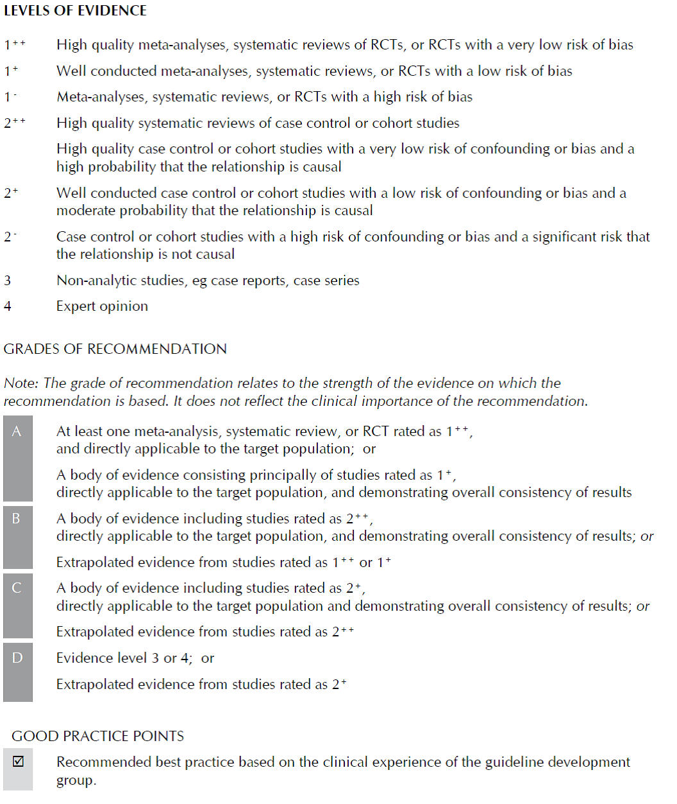

Lk. 8 - 11

Studies comparing the four-variable (also known as simplified) MDRD with Cockcroft-Gault give inconsistent results, though a majority indicate either comparable performance or superiority of MDRD over Cockcroft-Gault.88-90,92,102-111 These studies include the largest by far (>2,000 patients), in which comparison was made across a range of subgroups defined according to age, sex, true GFR, and BMI.106 **This study concluded that the MDRD formula provided more reliable estimations of kidney function than the CG formula.**

The MDRD equation is not completely accurate, and the extent of its inaccuracy varies between different patient groups. Even in the MDRD study population (patients with CKD) which was used to validate the equation, 9% of GFR estimates were 30% or more out with the isotope measured values.81 **Estimates of GFR are even less accurate in populations with higher GFR (≥60 ml/min/1.73 m2 ).**106 **The tendency of MDRD to underestimate true GFR in this range results in a significant risk of false positive diagnosis of CKD**. **This makes it difficult to interpret estimated GFR values of ≥60 ml/min/1.73 m2 .**

In half of the studies identified, cystatin C was more sensitive than serum creatinine in detecting reduced GFR.87,90,93,94,97,103,117-119 In the remaining half, studies did not demonstrate superiority of either measure.85,86,88,89,92,95,96,116,120 Two studies93,94 out of twelve85-89,92-97,116 suggest that cystatin C is superior to Cockcroft-Gault; most of the rest show comparable performance with prediction equations.

24-HOUR URINARY CREATININE CLEARANCE **In most studies this method performs less well than prediction equations or cystatin C**, 85-87,91, 102,104, 121 although two studies found little difference.88,89 One study found it to be superior to prediction equations in assessing GFR in normoalbuminuric type 1 diabetic patients and healthy controls;113 this may reflect the high GFR of the study population and the carefully controlled study conditions.

**Where an assessment of glomerular filtration rate is required prediction equations should be used in preference to 24-hour urine creatinine clearance or serum creatinine alone. (C)**

Prediction equations are more accurate than serum creatinine or 24-hour urine creatinine clearance in the assessment of GFR. 24-hour urine creatinine clearance is inconvenient and imprecise, and offers no advantages over prediction equations in most patients. The literature comparing cystatin C with serum creatinine is inconclusive. Prediction equations are at least as good in the detection of reduced GFR as cystatin C.

**Kidney Disease: Improving Global Outcomes (KDIGO) CKD Work Group. KDIGO 2012 Clinical Practice Guideline for the Evaluation and Management of Chronic Kidney Disease. Kidney inter., Suppl. 2013; 3: 1–150.**

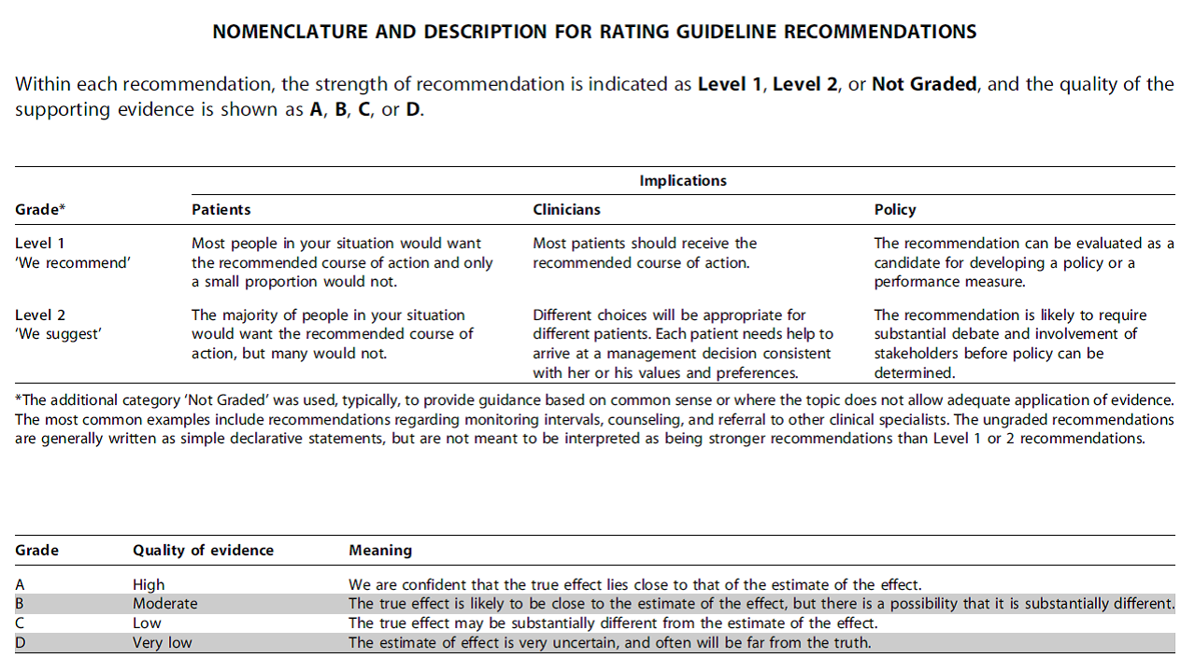

1.4.3.1: **We recommend using serum creatinine and a GFR estimating equation for initial assessment. (1A)**

1.4.3.2: **We suggest using additional tests (such as cystatin C or a clearance measurement) for confirmatory testing in specific circumstances when eGFR based on serum creatinine is less accurate. (2B)**

1.4.3.3: **We recommend that clinicians (1B):**

**• use a GFR estimating equation to derive GFR from serum creatinine (eGFRcreat) rather than relying on the serum creatinine concentration alone.**

**• understand clinical settings in which eGFRcreat is less accurate.**

1.4.3.4: We recommend that clinical laboratories should (1B):

• measure serum creatinine using a specific assay with calibration traceable to the international standard reference materials and minimal bias compared to isotope-dilution mass spectrometry (IDMS) reference methodology.

• report eGFRcreat in addition to the serum creatinine concentration in adults and specify the equation used whenever reporting eGFRcreat.

• **report eGFRcreat in adults using the 2009 CKD-EPI creatinine equation**. An alternative creatinine-based GFR estimating equation is acceptable if it has been shown to improve accuracy of GFR estimates compared to the 2009 CKD-EPI creatinine equation.

When reporting serum creatinine

• We recommend that serum creatinine concentration be reported and rounded to the nearest whole number when expressed as standard international units (lmol/l) and rounded to the nearest 100th of a whole number when expressed as conventional units (mg/dl).

When reporting eGFRcreat:

• We recommend that eGFRcreat should be reported and rounded to the nearest whole number and relative to a body surface area of 1.73 m2 in adults using the units ml/min/1.73 m2.

• **We recommend eGFRcreat levels less than 60 ml/min/1.73 m2 should be reported as ‘‘decreased.’’**

**1.4.3.5: We suggest measuring cystatin C in adults with eGFRcreat 45–59 ml/min/1.73 m2 who do not have markers of kidney damage if confirmation of CKD is required. (2C)**

**• If eGFRcys/eGFRcreat-cys is also <60 ml/min/1.73 m2, the diagnosis of CKD is confirmed.**

**• If eGFRcys/eGFRcreat-cys is ≥60 ml/min/1.73 m2, the diagnosis of CKD is not confirmed.**

1.4.3.6: If cystatin C is measured, we suggest that health professionals (2C):

• use a GFR estimating equation to **derive GFR from serum cystatin C** rather than relying on the serum cystatin C concentration alone.

• **understand clinical settings in which eGFRcys and eGFRcreat-cys are less accurate**.

1.4.3.7: We recommend that clinical laboratories that measure cystatin C should (1B):

• measure serum cystatin C using an assay with calibration traceable to the international standard reference material.

• report eGFR from serum cystatin C in addition to the serum cystatin C concentration in adults and specify the equation used whenever reporting eGFRcys and eGFRcreat-cys.

• report eGFRcys and eGFRcreat-cys in adults using the 2012 CKD-EPI cystatin C and 2012 CKD-EPI creatinine-cystatin C equations, respectively, or alternative cystatin C-based GFR estimating equations if they have been shown to improve accuracy of GFR estimates compared to the 2012 CKD-EPI cystatin C and 2012 CKD-EPI creatinine-cystatin C equations.

When reporting serum cystatin C:

• We recommend reporting serum cystatin C concentration rounded to the nearest 100th of a whole number when expressed as conventional units (mg/l).

When reporting eGFRcys and eGFRcreat-cys:

• We recommend that eGFRcys and eGFRcreat-cys be reported and rounded to the nearest whole number and relative to a body surface area of 1.73 m2 in adults using the units ml/min/1.73 m2.

• **We recommend eGFRcys and eGFRcreat-cys levels less than 60 ml/min/1.73 m2 should be reported as ‘‘decreased.’’**

1.4.3.8: **We suggest measuring GFR using an exogenous filtration marker under circumstances where more accurate ascertainment of GFR will impact on treatment decisions. (2B)**

Lk 38:

For most clinical circumstances, estimating GFR from SCr is appropriate for diagnosis, staging, and tracking the progression of CKD. However, like all diagnostic tests, interpretation is influenced by varying test characteristics in selected clinical circumstances and the prior probability of disease. In particular, an isolated decreased eGFR in otherwise healthy individuals is more likely to be false positive than in individuals with risk factors for kidney disease or markers of kidney damage. Confirmation of decreased eGFR by measurement of an alternative endogenous filtration marker (cystatin C) or a clearance measurement is warranted in specific circumstances when GFR estimates based on SCr are thought to be inaccurate and when decisions depend on more accurate knowledge of GFR, such as confirming a diagnosis of CKD, determining eligibility for kidney donation, or adjusting dosage of toxic drugs that are excreted by the kidneys.79 The choice of confirmatory test depends on the clinical circumstance and the availability of methods where the patient is treated.

lk 38 - 40

Using GFR estimating equations provides a more direct assessment of GFR than SCr alone. The SCr concentration is influenced by GFR and other physiological processes, collectively termed **‘‘non-GFR determinants,’’ including creatinine generation by muscle and dietary intake, tubular creatinine secretion by organic anion transporters, and extrarenal creatinine elimination by the gastrointestinal tract.** GFR estimating equations are developed using regression to relate the measured GFR to steady state SCr concentration and a combination of demographic and clinical variables as surrogates of the non-GFR determinants of SCr. **By definition, GFR estimates using SCr concentration are more accurate in estimating measured GFR than the SCr concentration alone in the study population in which they were developed.** Sources of error in GFR estimation from SCr concentration include nonsteady state conditions, non-GFR determinants of SCr, measurement error at higher GFR, and interferences with the creatinine assays. Because of the physiologic and statistical considerations in developing GFR estimating equations, **GFR estimates are less precise at higher GFR levels than at lower levels.** **In principle, equations based on multiple endogenous filtration markers can overcome some of the imprecision of GFR estimates at higher levels, due to cancellation of errors from noncorrelated non-GFR determinants.**

Variation in assigned values for SCr concentration among methods is greater at low concentrations, corresponding to high levels of GFR. Variation in assays at low SCr concentrations contributes to imprecision of GFR estimates at high GFR levels. In general, GFR estimating equations using creatinine include age, sex, race, and body size as surrogates for creatinine generation by muscle. 85 Based on published data, only the Modification of Diet in Renal Disease (MDRD) Study equation, Chronic Kidney Disease Epidemiology Collaboration (CKD-EPI) equation and modifications of these equations were developed using creatinine assays traceable to the international reference material for creatinine.86,87 The Cockcroft and Gault formula and others were developed before standardization of creatinine assays but cannot be re-expressed for use with standardized creatinine assays.

The MDRD Study equation was developed in 1999 and is currently recommended for eGFR reporting in adults by the National Kidney Disease Education Program (NKDEP) and by the Department of Health in the UK. It uses standardized SCr, age, sex, and race (black versus white and other) to estimate GFR adjusted for BSA (ml/min/1.73 m2).86,94 Because of imprecision at higher GFR, NKDEP recommends that eGFR >60 ml/min/1.73 m2 computed using the MDRD Study equation not be reported as a numeric value. For a similar reason, the UK Department of Health recommends not reporting eGFR >90 ml/min/1.73 m2 using the MDRD Study equation as a numeric value.

The CKD-EPI equation was developed in 2009 and uses the same four variables as the MDRD Study equation.87 **The CKD-EPI equation had less bias than the MDRD Study equation, especially at GFR>60 ml/min/1.73m2, a small improvement in precision, and greater accuracy.**

Most but not all studies from North America, Europe and Australia show that the CKD-EPI equation is more accurate than the MDRD Study equation, especially at higher GFR85, which enables reporting of numeric values across the range of GFR. **Lesser bias of the CKD-EPI equation compared to the MDRD Study equation reflects higher eGFR throughout most of the range for age and creatinine, especially in younger individuals, women and whites. Higher eGFR results in lower prevalence estimates for CKD in these groups, with more accurate risk relationships of lower eGFR and adverse outcomes**107.

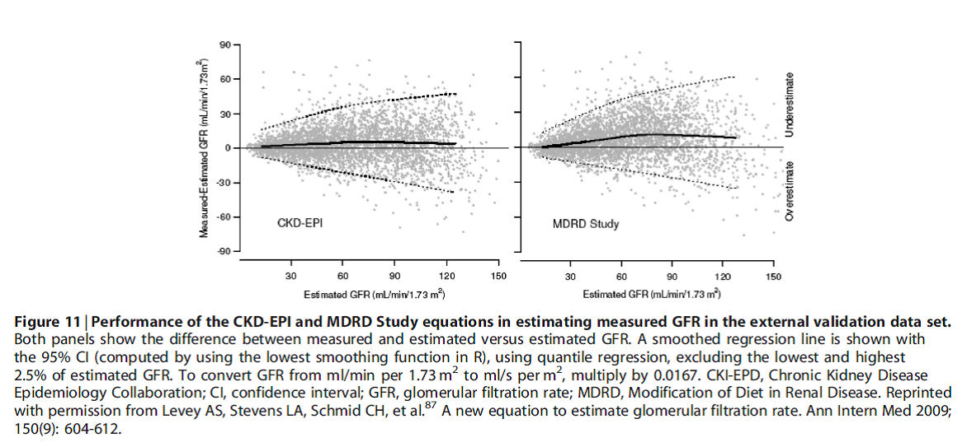

lk.46– 47

Abundant evidence has shown that GFR estimates based on cystatin C are more powerful predictors of clinical outcomes than creatinine-based eGFR. These findings have been strongest for mortality and CVD events, and the prognostic advantage of cystatin C is most apparent among individuals with GFR >45 ml/min/1.73m2. In addition, new findings show that **using cystatin C in addition to SCr can lead to improved accuracy of GFR estimation, including CKD classification.**

Evidence supports the use of cystatin C-based eGFR within the population of persons diagnosed with CKD based on an eGFRcreat 45-59 l/min/1.73 m2 (G3a) but without albuminuria (A1) or other manifestations of kidney damage. Data described below indicate that use of cystatin C to estimate GFR in this population leads to more accurate estimation of GFR and prediction of risk for future adverse events.

**New data from CKD-EPI also showed improved accuracy in GFR estimation using both creatinine and cystatin C (eGFRcreat-cys) compared to either marker alone**. In the subgroup with eGFRcreat 45-59 ml/min/1.73m2, the combined equation correctly reclassified 16.8% of those with eGFR 45-59 ml/min/1.73m2 to measured GFR ≥60 ml/min/1.73m2.113

**In addition to the population described above, eGFRcys may be useful as a confirmatory test in situations where either the eGFRcreat may be inaccurate or biased, or when the clinical scenario warrants a secondary test**. In these clinical situations, a clearance measurement using an exogenous filtration marker may be optimal when it is available. The measurement of eGFRcys/eGFRcreat-cys would be a relatively low-cost, feasible alternative when GFR measurement is not practical. **The Work Group believed that measured urinary CrCl was an inferior confirmatory test relative to either GFR measurement or GFR estimation using both creatinine and cystatin C.**

**National Clinical Guideline Centre; National Institute for Health and Care Excellence. Chronic kidney disease (partial update). Early identification and management of chronic kidney disease in adults in primary and secondary care. 2014**

Creatinine-based estimate of GFR

1.1.1 Whenever a request for serum creatinine measurement is made, clinical laboratories should report an estimate of glomerular filtration rate (eGFRcreatinine) using a prediction equation (see recommendation 1.1.2) in addition to reporting the serum creatinine result. [2014]

1.1.2 Clinical laboratories should:

• use the Chronic Kidney Disease Epidemiology Collaboration (CKD EPI) creatinine equation to estimate GFRcreatinine, using creatinine assays with calibration traceable to standardised reference material

• use creatinine assays that are specific (for example, enzymatic assays) and zero-biased compared with isotope dilution mass spectrometry (IDMS)

1.1.3 Apply a correction factor to GFR values estimated using the CKD EPI creatinine equation for people of African-Caribbean or African family origin (multiply eGFR by 1.159). [new 2014]

1.1.4 In people with extremes of muscle mass – for example, in bodybuilders, people who have had an amputation or people with muscle wasting disorders – interpret eGFRcreatinine with caution. (Reduced muscle mass will lead to overestimation and increased muscle mass to underestimation of the GFR.) [2008]

1.1.5 Advise people not to eat any meat in the 12 hours before having a blood test for eGFRcreatinine. Avoid delaying the despatch of blood samples to ensure that they are received and processed by the laboratory within 12 hours of venepuncture. [2008]

Cystatin C-based estimate of GFR

1.1.6 Whenever a request for serum cystatin C measurement is made, clinical laboratories should report an estimate of glomerular filtration rate (eGFRcystatinC) using a prediction equation (see recommendation 1.1.7) in addition to reporting the serum cystatin C result. [new 2014]

1.1.7 When an improved assessment of risk is needed (see recommendation 1.1.14), clinical laboratories should use the CKD EPI cystatin C equation to estimate GFRcystatinC. [new 2014]

1.1.8 Clinical laboratories should use cystatin C assays calibrated to the international standard to measure serum cystatin C for cystatin C-based estimates of GFR. [new 2014]

1.1.9 Interpret eGFRcystatinC with caution in people with uncontrolled thyroid disease because eGFRcystatinC values may be falsely elevated in people with hypothyroidism and reduced in people with hyperthyroidism. [new 2014]

Reporting and interpreting GFR values

1.1.10 Clinical laboratories should report GFR either as a whole number if it is 90 ml/min/1.73 m2 or less, or as 'greater than 90 ml/min/1.73 m2'. [new 2014]

1.1.11 If GFR is greater than 90 ml/min/1.73 m2, use an increase in serum creatinine concentration of more than 20% to infer significant reduction in kidney function. [new 2014]

1.1.12 Interpret eGFR values of 60 ml/min/1.73 m2 or more with caution, bearing in mind that estimates of GFR become less accurate as the true GFR increases. [2014]

1.1.13 Confirm an eGFR result of less than 60 ml/min/1.73 m2 in a person not previously tested by repeating the test within 2 weeks. Allow for biological and analytical variability of serum creatinine (±5%) when interpreting changes in eGFR. [2008]

When to use a cystatin C-based estimate of GFR for diagnosis of CKD

1.1.14 Consider using eGFRcystatinC at initial diagnosis to confirm or rule out CKD in people with:

• an eGFRcreatinine of 45–59 ml/min/1.73 m2, sustained for at least 90 days and

• no proteinuria (albumin:creatinine ratio [ACR] less than 3 mg/mmol) or other marker of kidney disease. [new 2014] (Markers of kidney disease: These include albuminuria (ACR more than 3 mg/mmol), urine sediment abnormalities, electrolyte and other abnormalities due to tubular disorders, abnormalities detected by histology, structural abnormalities detected by imaging, and a history of kidney transplantation.)

1.1.15 Do not diagnose CKD in people with:

• an eGFRcreatinine of 45–59 ml/min/1.73 m2 and

• an eGFRcystatinC of more than 60 ml/min/1.73 m2 and

• no other marker of kidney disease. [new 2014]

When highly accurate measures of GFR are required

1.1.16 Where a highly accurate measure of GFR is required – for example, during monitoring of chemotherapy and in the evaluation of renal function in potential living donors – consider a reference standard measure (inulin, 51Cr EDTA, 125I iothalamate or iohexol). [2008]



Lk. 103-104; 64 – 65

The GDG noted that although the biochemical assay for creatinine is precise, a number of factors affect serum creatinine concentrations; particularly the person’s state of hydration and whether they had recently eaten meat. Serum creatinine concentrations also show diurnal variation. This means that the eGFR derived using the 4-variable MDRD equations will also be affected by these factors.

When making a diagnosis of CKD, assessing the stage of CKD, or monitoring patients for evidence of declining kidney function, it is important that clinicians are aware of the factors that can influence creatinine concentrations. It was recommended that whenever possible they take steps to minimise the biases that these factors introduce and that they are aware that **changes of less than 5% may simply be due to biological and analytical variability.**

Creatinine is subject to non-renal and analytical influences which, on its own, make it insufficiently sensitive to detect moderate CKD. Theoretically, measurement of 24-hour urinary creatinine clearance could improve the accuracy of measurement of kidney function. However, this is also subject to the same non-renal and analytical influences compounded by inaccuracies in urine collection and tubular secretion of creatinine, in addition to the inconvenience associated with 24-hour urine collections.

An alternative and more accurate endogenous marker is cystatin C, a 13 kDa cationic protein produced by all nucleated cells. Plasma cystatin C concentrations are chiefly determined by GFR.

**The accuracy of both serum creatinine and cystatin C for detecting reduced kidney function can be improved through use of equations to estimate GFR which correct for some of the more significant non-renal influences. This approach is known to be more sensitive for the detection of CKD than serum creatinine and more accurate than creatinine clearance.**

Lk. 66-76; 102

Ravijuhendi raames on koostatud süstemaatiline ülevaade, mille eesmärk on hinnata erinevate eGFR-i valemite täpsust neerufunktsiooni määramisel:

Review question: What is the accuracy of equations to estimate GFR as a measurement of kidney function?

Süstemaatiline ülevaade põhineb 15 uuringul (otsing al.2007a.; uuringus min. 100 uuritavat). Ülevaates võrreldakse CKD-EPI kreatiniinil ning tsüstatiin C-l põhinevaid valemeid ja CKD-EPI kombineeritud (kreatiniin + tsüstatiin C) valemit MDRD valemiga. Referentsuuringuna kasutatakse välisel markeril põhinevat GFR-i mõõtmist.

Kriitilised tulemusnäitajad:

• Bias - difference between estimates of GFR and the true value as measured by a reference technique

• Precision - variability of the estimate of GFR compared to the measured value.

• Accuracy (P30) - percentage of estimated GFR values lying within 30% of the measured GFR.

All of the following are based on high quality evidence:

**The studies did not show an important difference in accuracy of estimating kidney function, defined by P30, between MDRD and CKD-EPI. There was, however a trend towards increased accuracy using cystatin C or combined equations.** P30 was slightly better in the subgroup with GFR <60 ml/min/1.73 m2 compared to a GFR >60 ml/min/1.73 m2. The CKD-EPI creatinine equation was more accurate than the MDRD in people with a GFR >60 ml/min/1.73 m2.

Three studies included only older people: Kilbride et al196 people aged 74 years and over (median 80 years) and both Koppe et al203 and Schaeffner et al366 people aged over 70. In the Kilbride study the P30 of all the CKD-EPI equations was significantly better than that of the MDRD equation in those with GFR greater than 60 ml/min/1.73 m2. Overall the three studies showed a trend towards CKD-EPI creatinine, cystatin C or combined equations being more accurate than MDRD in this subgroup.

**In people aged over 70 years there was some evidence that eGFR cystatin C was more accurate than the combined eGFR creatinine-cystatin C equation, but this was only from one study.366 However, the evidence does show that the CKD EPI creatinine equation correctly identifies more people with GFR <60 ml/min/1.73 m2 in people over the age of 75 than MDRD.**

**Overall there was less bias with the CKD-EPI creatinine equation than with MDRD.** There was more bias in the GFR>60 ml/min/1.73 m2 subgroup compared to the GFR<60 ml/min/1.73 m2. Cystatin C or combined equations showed the least bias in the GFR <60 ml/min/1.73 m2 group. In the GFR>60 ml/min/1.73 m2 group there was minimal difference between the performance of the equations. Only two studies reported bias in the older population subgroup. Both showed less bias with cystatin C or combined equations compared to creatinine based equations alone.

**The most precise equation was the combined CKD EPI** (serum creatinine and cystatin C) however, overall there was little difference in precision between the equations.

There was no difference in sensitivity and specificity or area under the curve for CKD EPI creatinine compared to MDRD.

**Neither the CKD-EPI nor the MDRD Study equation is optimal for all populations and GFR ranges.97 However, a general practice and public health perspective favoured the CKD-EPI equation as a better predictor of risk of adverse outcome and there is more to gain in absolute terms if people with CKD are correctly identified.249**

Lk.105

The data reviewed suggested that in people with no proteinuria confirmation of a creatinine-based estimate of GFR 45-59 ml/min/1.73 m2 with a cystatin C-based eGFR <60 ml/min/1.73 m2 identified those at greater risk of adverse outcomes related to CKD diagnosis. Conversely, **those not confirmed by a cystatin C-based GFR <60 were at no greater risk than people without CKD**. The GDG agreed this was important to note as there is concern that there has been over diagnosis of people with CKD who fall within this group, and therefore confirmation of diagnosis with a cystatin C-based eGFR would help address this over-diagnosis.

Lk.101; 76; 106.

Ravijuhendi raames on koostatud kulutõhususe analüüs:

**The CKD EPI creatinine equation is no more costly than the MDRD creatinine equation to** **implement** – both equations are based on age, sex, ethnicity and serum creatinine level. Since it is less biased and more precise than the MDRD equation, it is likely to be more cost-effective.

CKD-EPIcys was less costly than CKD-EPIcreatinine and CKD-EPIcreat-cys for diagnosing CKD in people with an initial CKD-EPIcreatinine 45-59, ACR<3mg/mmol and without diabetes (magnitude of cost savings varied according to age group, comorbidity, time horizon and re-testing strategy).

**In all cohorts, the CKD-EPIcystatin equation produced the fewest false positive results, which led to it being the lowest cost strategy** - the cost of the test being more than offset by the subsequent reduction in drug and management costs. In the cohort of older patients and the cohort of non-hypertensive patients, the CKD-EPIcreat-cys equation had the most accurate diagnoses since it had fewer false negative results due to its greater sensitivity.

Ravijuhendi lisamaterjal. Implementation: Getting started

**The Chronic Kidney Disease Epidemiology Collaboration (CKD-EPI) creatinine equation is more accurate than the Modification of Diet in Renal Disease (MDRD) Study equation, is less biased at a GFR of more than 60 ml/min/1.73 m2 and performs better in people aged 75 years and over. The use of the MDRD Study equation may over-diagnose CKD. Using the CKD-EPI equation instead could benefit patients and clinicians by reducing unnecessary appointments, reducing patients' concerns and reducing the overall burden of CKD in the population.**

**Estimates of GFR (eGFR) based on serum cystatin C have a higher specificity for significant disease outcomes than those based on serum creatinine. For people with a borderline diagnosis, eGFRcystatinC is an additional diagnostic tool that may reduce over diagnosis. Using this tool may result in a significant proportion of people classified as having stage 3 CKD being reclassified as not having CKD (G1A1 or G2A1). This could benefit patients and clinicians by reducing unnecessary appointments, reducing patients' concerns and reducing the overall burden of CKD in the population. This additional test may have a cost impact, but there will be financial benefits, with fewer diagnoses leading to reduced management costs.**

**Süstemaatilised ülevaated**

Alates 2010. a. avaldatud süstemaatilistest ülevaadetest ja metaanalüüsidest, mis käsitlevad neerufunktsiooni määramise meetodeid, leidsime kaks sobivat. Üks neist (Van Pottelbergh, 2010) analüüsib erinevate neerufunktsiooni määramise meetodite täpsust eakatel, teine aga võrdleb erinevate glomerulaarfiltratsiooni mõõtmise meetodite (mGFR) täpsust (Soveri, 2014).

Esimeses süstemaatilises ülevaates võrreldakse neerufunktsiooni määramise meetoditena kreatiniini, kreatiniinil põhineva arvutusliku filtratsiooni (Cockcroft-Gault (CG); MDRD), kreatiniini kliirensi ja tsüstatiin C määramist üle 65-aastastel. Analüüsi tulemusena selgub, et seerumi kreatiniini kontsentratsiooni määramine on madala tundlikkusega meetod eakate neerufunktsiooni hindamiseks. Samuti leiti, et võrreldes CG ja MDRD valemitega korreleerub kreatiniini kliirensi mõõtmine 24 tunni uriinist halvemini kuldstandardiks peetavate neerufunktsiooni mõõtmise meetoditega. Hea korrelatsioon mõõdetud GFR-ga on nii MDRD ja CG alusel leitud arvutuslikul glomerulaarfiltratsiooni kiirusel kui ka tsüstatiin C-l. Kolm eelmainitud meetodit on ka hea tundlikkuse ja spetsiifilisusega. Kokkuvõtteks võib öelda, et üle 65-aastastel on parimaks neerufunktsiooni määramise meetodiks arvutusliku glomerulaarfiltratsioonil määramine. Seda, missugust valemit eelistada (CG või MDRD) ainult antud ülevaate analüüsile toetudes öelda ei saa. Tsüstatiin C kontsentratsiooni määramine on kõnealuses vanusegrupis paljutõotav uus neerufunktsiooni hindamise meetod, kuid kuna statistilisse analüüsi oli kaasatud vähe tsüstatiin C uuringuid, ei saa selle markeri lõplikke järeldusi teha.(Van Pottelbergh, 2010*)*

Teises süstemaatilises ülevaates võrreldakse GFR-i mõõtmismeetodeid. Antud ülevaatest selgub, et mGFR-i leidmisel on täpsemad eksogeenset filtratsioonimarkerit kasutavad meetodid. Autorid leiavad, et Kreatiniini kliirens on ebatäpne meetod neerufunktsiooni määramiseks. (Soveri, 2014).

**Viited**

|  |  |
| --- | --- |
| **Kokkuvõtte (abstract või kokkuvõtlikum info)** | **Viide kirjandusallikale** |
| **CONTEXT:**  multiple studies of elderly patients show that the prevalence of chronic renal failure in people aged 65 years and older is dependent on the method used to calculate the glomerular filtration rate. We performed a systematic literature search with research question: **What is the best method that could be applicable in clinical practice for evaluating renal function in the elderly?** Studies using inulin, Cr-51-EDTA, Tc-DTPA or iohexol assays as the gold standard were included.  **METHODS:**  we searched the PubMed and EMBASE databases. Articles found were screened first by title and abstract and then by five criteria. Retained articles were scored using an adapted version of QUADAS.  **RESULTS:**  twelve articles had an identified population or subpopulation aged 65 years and older. The studies were heterogeneous with regard to the population investigated and the statistical procedures used to compare the methods and equations with the gold standard. **The Cockcroft-Gault (CG) and MDRD equations and the serum cystatin C concentration produced the highest correlations with the gold standard.**  **CONCLUSIONS:**  no accurate method to evaluate renal function in the elderly was found. **Serum cystatin C concentration and the CG and MDRD formula might be valuable parameters, although there is insufficient evidence.**  The sensitivity and positive predictive values of the combined studies are shown in Figure 2, which presents the sensitivity at the 60 ml/min limit for the combined data and for the individual studies. Comparison of the pooled sensitivity of the various methods (Figure 2) showed that serum creatinine concentration is very poor at detecting disease. The sensitivity of the CG formula seems to be 80–100% for the various cut-off values. The MDRD formula gives a similar percentage, except for the results for the 50 ml/min limit, which indicate  a sensitivity of circa 60%. This value for 50 ml/min comes from one article of 52 patients by Lamb et al. in 2003, and its significance is questionable. The sensitivity values for creatinine clearance fluctuate between 64 and 93% and  for cystatin C concentration between 86 and 97%.  We compared the various studies in more detail around the cut-off point of 60 ml/min (Figure 2) because this is a clinically relevant value. Below this value, a patient is considered to have renal failure. At this cut-off value, the CG formula seems to score better than the MDRD equation. However, the sensitivity of the MDRD equation around 60 ml/min was calculated from only one study, by Burkhardt et al. [21]. This study also calculated the sensitivity of the CG formula, which produced a significantly lower value. | Van Pottelbergh, G. et.al.  [**Methods to evaluate renal function in elderly patients: a HYPERLINK "http://www.ncbi.nlm.nih.gov/pubmed/20716584"systematicHYPERLINK "http://www.ncbi.nlm.nih.gov/pubmed/20716584" literature review**HYPERLINK "http://www.ncbi.nlm.nih.gov/pubmed/20716584".](http://www.ncbi.nlm.nih.gov/pubmed/20716584)  **Age Ageing. 2010 Sep;39(5):542-8.** |
| **BACKGROUND:**  No comprehensive systematic review of the accuracy of glomerular filtration rate (GFR) measurement methods using renal inulin clearance as reference has been published.  **STUDY DESIGN:**  Systematic review with meta-analysis of cross-sectional diagnostic studies.  **SETTING & POPULATION:**  Published original studies and systematic reviews in any population.  **SELECTION CRITERIA FOR STUDIES:**  Index and reference measurements conducted within 48 hours; at least 15 participants studied; GFRmarkers measured in plasma or urine; plasma clearance calculation algorithm verified in another study; tubular secretion of creatinine had not been blocked by medicines.  **INDEX TESTS:**  Endogenous creatinine clearance; renal or plasma clearance of iohexol, iothalamate, chromium 51-labeled ethylenediaminetetraacetic acid (51Cr-EDTA) and diethylenetriaminepentaacetic acid (DTPA); and plasma clearance of inulin.  **REFERENCE TEST:**  Renal inulin clearance measured under continuous inulin infusion and urine collection.  **RESULTS:**  Mean bias <10%, median bias <5%, the proportion of errors in the index measurements that did not exceed 30% (P30) ≥80%, and P10 ≥50% were set as requirements for sufficient accuracy. Based on the GRADE (Grading of Recommendations Assessment, Development and Evaluation) approach, the quality of evidence across studies was rated for each index method.  Renal clearance of iothalamate measured GFR with sufficient accuracy (strong evidence). Renal and plasma clearance of 51Cr-EDTA and plasma clearance of iohexol were sufficiently accurate to measure GFR (moderately strong evidence). Renal clearance of DTPA, renal clearance of iohexol, and plasma clearance of inulin had sufficient accuracy (limited evidence). **Endogenous creatinine clearance was an inaccurate method (strong evidence)**, as was plasma clearance of DTPA (limited evidence). The evidence to determine the accuracy of plasma iothalamate clearance was insufficient. With the exception of plasma clearance of inulin, only renal clearance methods had P30 >90%.  **LIMITATIONS:**  The included studies were few and most were old and small, which may limit generalizability. Requirements for sufficient accuracy may depend on clinical setting.  **CONCLUSIONS:**  At least moderately strong evidence suggests that renal clearance of 51Cr-EDTA or iothalamate and plasma clearance of 51Cr-EDTA or iohexol are sufficiently accurate methods to measure GFR. | Soveri,I. et. al.  [**Measuring GFR: a HYPERLINK "http://www.ncbi.nlm.nih.gov/pubmed/24840668"systematicHYPERLINK "http://www.ncbi.nlm.nih.gov/pubmed/24840668" review.**](http://www.ncbi.nlm.nih.gov/pubmed/24840668)  Am J Kidney Dis. 2014 Sep;64(3):411-24. |