Madala(ma) trombembooliariskiga KVA patsiendi antitrombootiline ravi – kliinilise tõenduse kokkuvõte

Kliiniline küsimus
Kas madala(ma) trombembooliariskiga KVA patsientidel tuleks tromboprofülaktikaks kasutada antiagregante vs ei midagi vs antikoagulante?

Olulised tulemusnäitajad
Surm, ajuinfarkt, trombemboolia, oluline verejooks, elukvaliteet, koljusisene verejooks, tõsine kõrvaltoime.

CHA2DS2-VASc skoor ja atsetüülsalitsüülhape (ASH)
Puuduvad randomiseeritud kliinilised uuringud, mis hindaks ASH kasutamist ajuinsuldi madala riskiga patsientidel (CHA2DS2-VASc = 0 meestel ja ilma ühegi lisariskita naistel).
Cochrane ülevaade (Aguilar 2005) leidis 3 uuringut, mis uurisid ASH annustes 75 mg kuni 325 mg päevas ja 125 mg ülepäeva võrreldes platseeboga (2 uuringut) ja kontrolliga (1 uuring) kokku 1965 KVA patsiendil ilma eelneva ajuinsuldi ja TIA-ta.
Aspiriini kasutamine vähendas statistiliselt mitteoluliselt ajuinsuldi (šansisuhe (OR) 0.70, 95% CI 0.47 - 1.07), isheemilise insuldi (OR 0.70, 95% CI 0.46 - 1.07), fataalse insuldi (OR 0.86, 95% CI 0.50 - 1.49) üldsuremuse (OR 0.75, 95% CI 0.54 - 1.04) riski. Intrakraniaalse verejooksu või olulise ekstrakraniaalse verejooksu oht ei suurenenud. Antud uuringutes ei olnud täpsustatud CHA2DS2-VASc skoor.
1 uuringu andmetest (Coppens et al. Tabel 4) leiab CHA2DS2-VASc 1 skooriga ja aspiriini tarvitavatel KVA patsientidel (mehed) esineva isheemilise ajuinsuldi, täpsustamata ajuinsuldi ja mitte-kesknärvisüsteemi emboli haigestumuskordaja 1,1 (0,6-1,8) 100 patsient-aasta kohta, HR 1.
CHA2DS2-VASc 2 ja aspiriini tarvitavate KV patsientide puhul oli haigestumuskordaja 2.3 (1.8–3.1), HR 2,2 (95% CI 1,3-3,9).
CHA2DS2-VASc skoor ja antiagregantravi
Soovitused ravijuhendites mõõduka riskiga patsientide (CHA2DS2-VASc = 1 meestel ja CHA2DS2-VASc = 2 naistel) antikoagulantravi kohta tulenevad peamiselt vaatlusuuringutest, kus hinnati ajuinsuldi tekkeriski patsientidel, kes antikoagulantravi ei saanud. Uuringute tulemused on varieeruva ajuinsuldi esinemissagedusega, sõltuvalt erinevatest populatsioonidest ja antikoagulantravi staatusest.
Seetõttu viis ESC läbi omapoolse kohortuuringu andmetest (Allen 2016, web table 1, viimane rida), kus võrreldis CHA2DS2-VASc skoori järgi isheemilise insuldi esinemissagedust varfariin raviga vs ilma antitrombootilise ravita.
Tulemused:
CHA₂DS₂-VASc=0 (IR (95% CI)/100 PY: 0.4 (0.2 to 0.8) vs 0.2 (0.1 to 0.3), p value=0.16).
CHA₂DS₂-VASc=1 IR (95% CI)/100 PY: 0.4 (0.3 to 0.7) vs 0.7 (0.6 to 0.8), p value=0.03)
CHA₂DS₂-VASc=2 (IR (95% CI)/100 PY: 0.8 (0.7 to 1.0) vs 1.4 (1.3 to 1.6), p value=0.00).
Uuringu autorite sõnul oli varfariini kliiniline netokasu (net clinical benefit - NCB) märgatav alates CHA₂DS₂-VASc ≥ 2 meestel ja ≥ 3 naistel.

Lühike kokkuvõte ravijuhendite soovitustest samal teemal
ESC 2016 soovitab CHA2DS2-VASc = 0 korral antitrombootilist ravi mitte kasutada. Madala trombemboolia riski korral (CHA2DS2-VASc = 1 meestel ja CHA2DS2-VASc = 2 naistel) korral soovitab ESC 2016 suukaudset antikoagulantravi kaaluda, arvestades patsiendi eelistustega, veritsusriskiga ja erinevate riskifaktorite tähtsusega (vanus >65 on oluline ja püsivalt suureneva mõjuga riskifaktor). Ilma insuldi riskifaktoriteta KVA patsientidel ei ole antiagregant (ega antikoagulant) soovitav (IIIB). Antiagregant monoteraapiana ei ole insuldi profülaktikaks soovitav (IIIA).
AHA 2014 soovitab CHA2DS2-VASc = 0 korral antitrombootilist ravi mitte kasutada (IIA, B). CHA2DS2-VASc = 1 korral soovitatakse antitrombootilist ravi mitte rakendada, kasutada antikoagulantravi või aspiriini (IIB, C).
NICE 2014 ravijuhend soovitab CHA2DS2-VASc = 0 skooriga meestele ja CHA2DS2-VASc = 1 naistele antitrombootilist ravi mitte rakendada. Ravijuhend soovitab kaaluda CHA2DS2-VASc = 1 meestel antikoagulantravi rakendamist, arvestades veritsusriski.
Kanada ravijuhend soovitab kasutada trombemboolia riskikalkulatsioonides CHADS2 kombineerides seda vanusega > 65 - nimetavad "CCS algoritmiks" – see pole 1/1 ülevõetav CHA2DS2-VASc skooringu numbritega.
SOOME ravijuhend soovitab CHA2DS2-VASc = 0 korral antitrombootilist ravi mitte kasutada. CHA2DS2-VASc = 1 korral soovitatakse kasutada antikoagulantravi või loobuda antitrombootilisest või antitrombootilisest ravist üldse.

ESC 2016
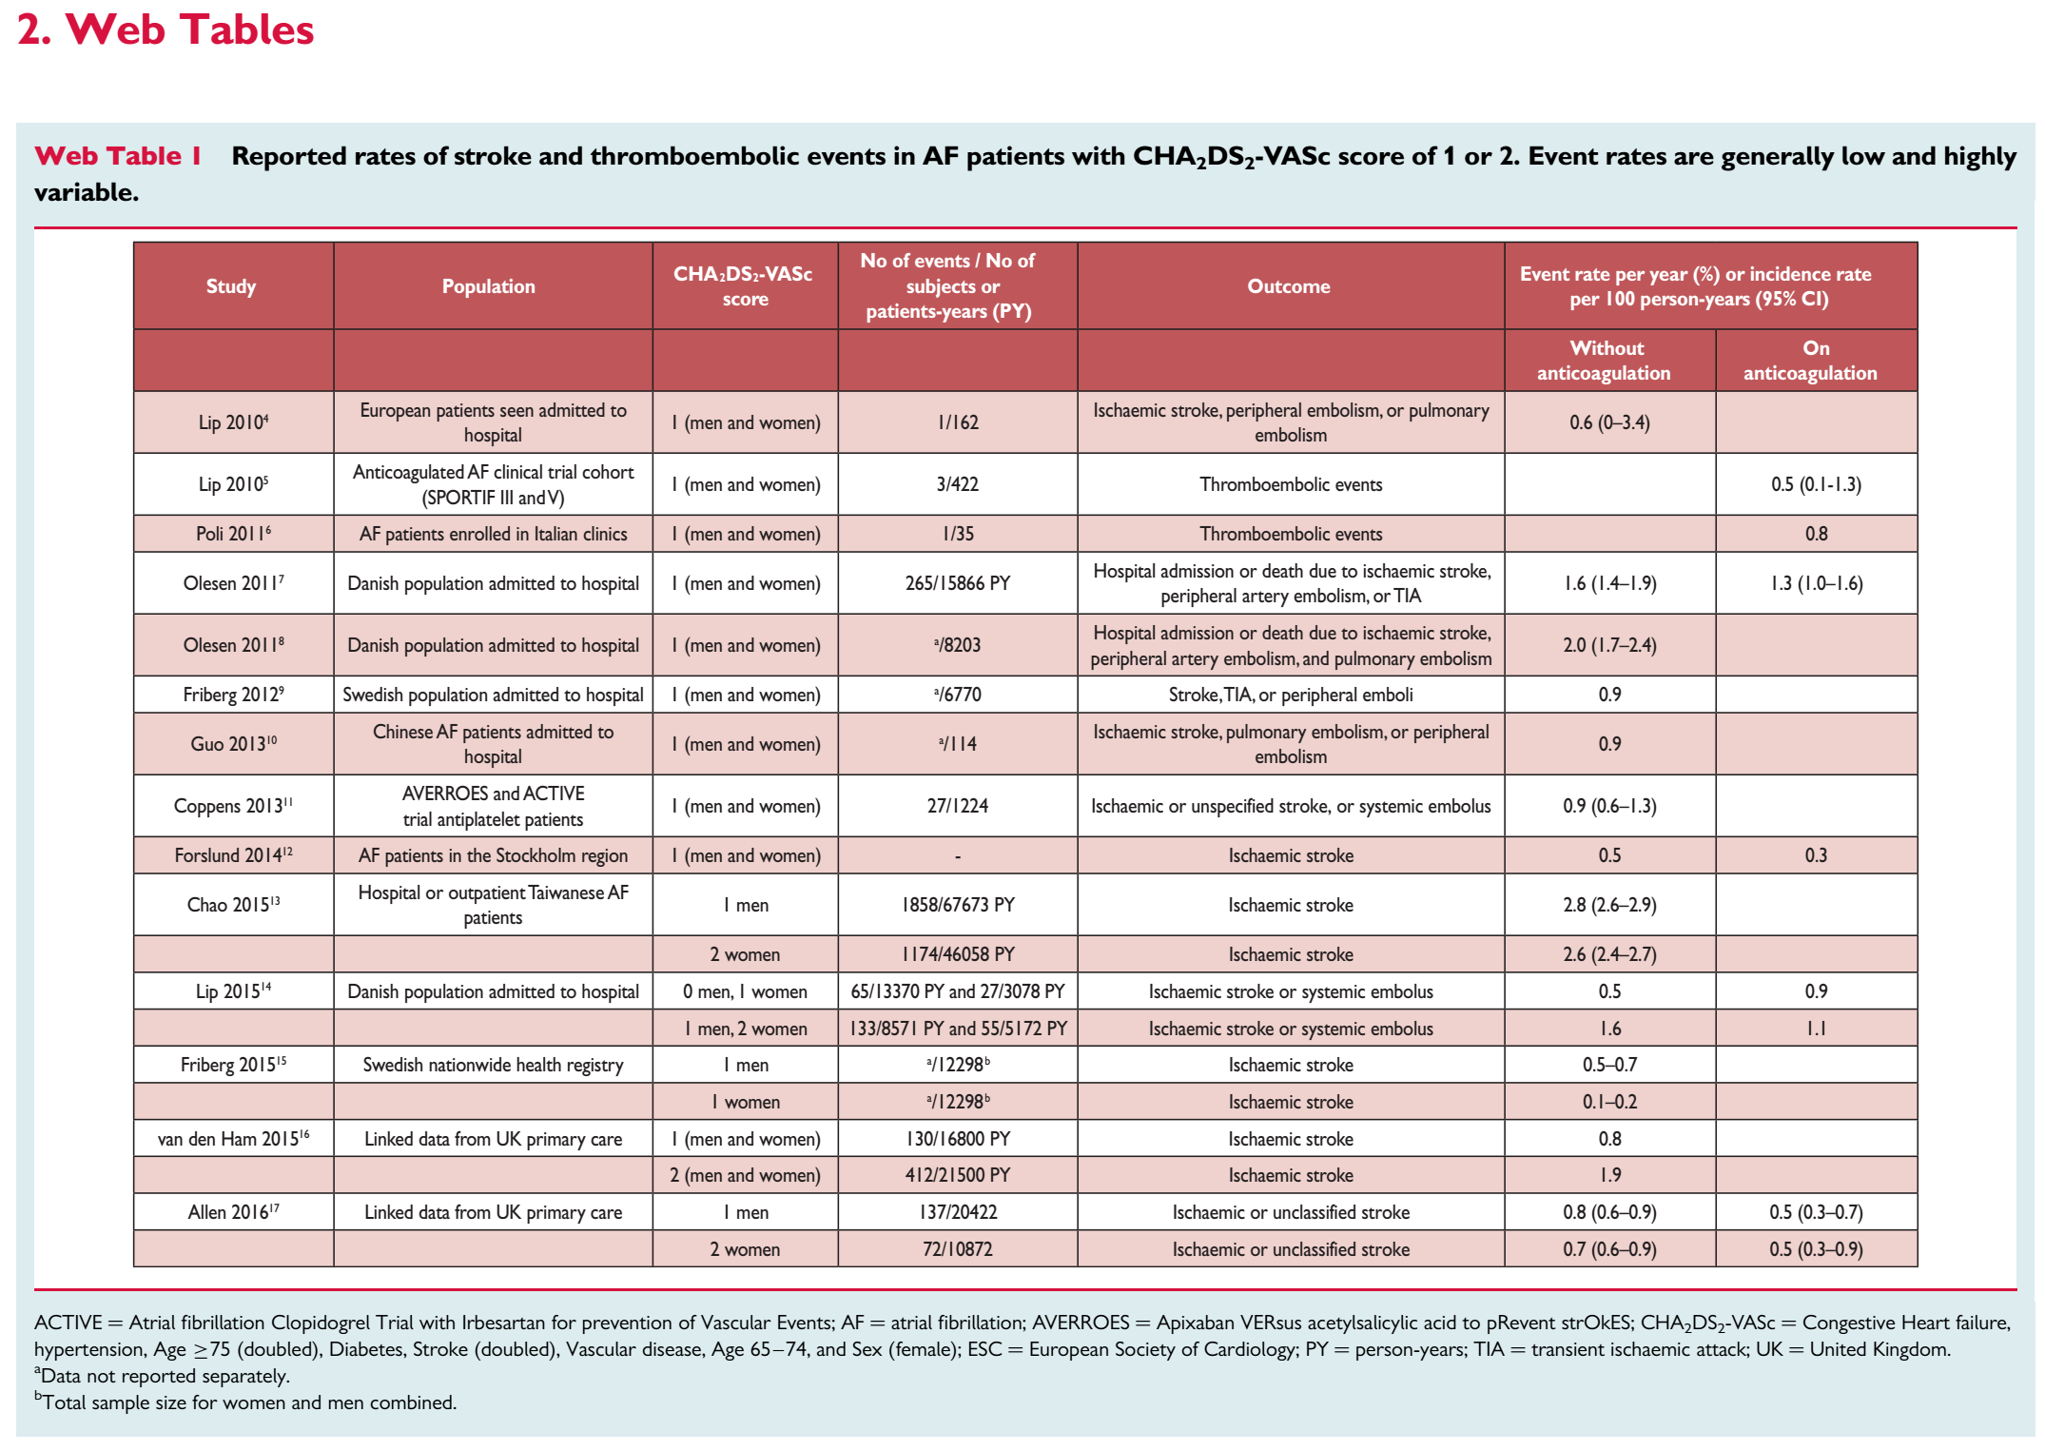

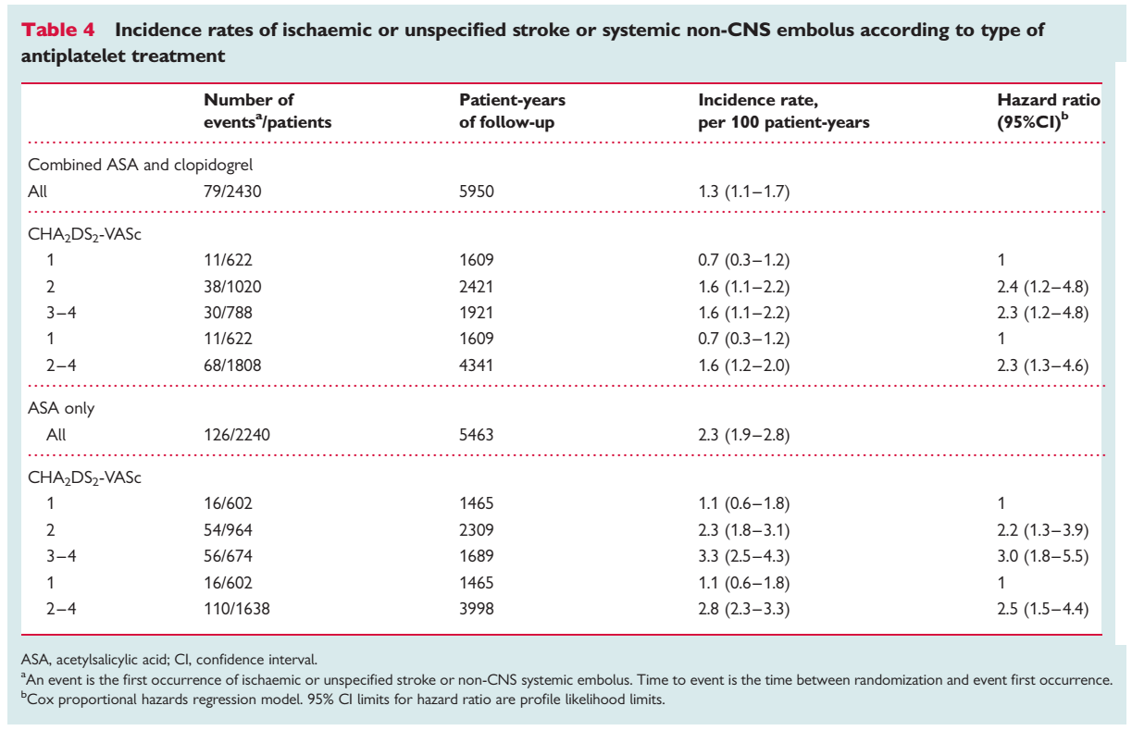
Tekstiline kokkuvõte tõendusest koos viidetega
BACKGROUND:  Non-valvular atrial fibrillation (AF) carries an increased risk of stroke. Antiplatelet therapy (APT) is proven effective for stroke prevention in most patients at high-risk for vascular events, but its value for primary stroke prevention in patients with non-valvular AF merits separate consideration because of the suspected cardioembolic mechanism of most strokes in AF patients.  OBJECTIVES:  To assess the efficacy and safety of long-term APT for primary prevention of stroke in patients with chronic non-valvular AF.  SEARCH STRATEGY:  We searched the Cochrane Stroke Group Trials Register (searched August 2004). In addition, we searched the Cochrane Central Register of Controlled Trials (The Cochrane Library Issue 1, 2005), MEDLINE (1966 to June 2004), and the reference lists of recent review articles. We also contacted experts working in the field to identify unpublished and ongoing trials.  SELECTION CRITERIA:  Randomized trials comparing long-term APT with placebo or control in patients with non-valvular AF and no history of transient ischemic attack (TIA) or stroke. A sensitivity analysis included one additional randomized trial involving primary prevention with aspirin plus very low dose warfarin.  DATA COLLECTION AND ANALYSIS:  Two authors independently selected trials for inclusion and extracted data for each outcome. Unpublished data were obtained from trial investigators.  MAIN RESULTS:  Three trials tested aspirin in dosages ranging from 75 mg to 325 mg per day and 125 mg every other day to placebo (in two trials) or control (in one trial) in 1965 AF patients without prior stroke or TIA. The mean duration of follow up averaged 1.3 years per participant. Aspirin was associated with non-significant lower risks of all stroke (odds ratio (OR) 0.70, 95% confidence interval (CI) 0.47 to 1.07), ischemic stroke (OR 0.70, 95% CI 0.46 to 1.07), all disabling or fatal stroke (OR 0.86, 95% CI 0.50 to 1.49) and all-cause death (OR 0.75, 95% CI 0.54 to 1.04). The combination of stroke, myocardial infarction or vascular death was significantly reduced (OR 0.71, 95% CI 0.51 to 0.97 ). No increase in intracranial hemorrhage or major extracranial hemorrhage was observed.  AUTHORS' CONCLUSIONS:  Aspirin appears to reduce stroke and major vascular events in patients with non-valvular AF similar to its effect in other high-risk patients (ie by about 25%). For primary prevention among AF patients with an average stroke rate of 4% per year, about 10 strokes would likely be prevented yearly for every 1000 AF patients given aspirin. | Aguilar M, Hart R. Antiplatelet therapy for preventing stroke in patients with non-valvular atrial fibrillation and no  previous history of stroke or transient ischemic attacks. Cochrane Database Syst Rev. 2005;CD001925.
BACKGROUND:  Atrial fibrillation is a strong independent risk factor for stroke.  PURPOSE:  To characterize the efficacy and safety of antithrombotic agents for stroke prevention in patients who have atrial fibrillation, adding 13 recent randomized trials to a previous meta-analysis.  DATA SOURCES:  Randomized trials identified by using the Cochrane Stroke Group search strategy, 1966 to March 2007, unrestricted by language.  STUDY SELECTION:  All published randomized trials with a mean follow-up of 3 months or longer that tested antithrombotic agents in patients who have nonvalvular atrial fibrillation.  DATA EXTRACTION:  Two coauthors independently extracted information regarding interventions; participants; and occurrences of ischemic and hemorrhagic stroke, major extracranial bleeding, and death.  DATA SYNTHESIS:  Twenty-nine trials included 28,044 participants (mean age, 71 years; mean follow-up, 1.5 years). Compared with the control, adjusted-dose warfarin (6 trials, 2900 participants) and antiplatelet agents (8 trials, 4876 participants) reduced stroke by 64% (95% CI, 49% to 74%) and 22% (CI, 6% to 35%), respectively. Adjusted-dose warfarin was substantially more efficacious than antiplatelet therapy (relative risk reduction, 39% [CI, 22% to 52%]) (12 trials, 12 963 participants). Other randomized comparisons were inconclusive. Absolute increases in major extracranial hemorrhage were small (< or =0.3% per year) on the basis of meta-analysis.  LIMITATION:  Methodological features and quality varied substantially and often were incompletely reported.  CONCLUSIONS:  Adjusted-dose warfarin and antiplatelet agents reduce stroke by approximately 60% and by approximately 20%, respectively, in patients who have atrial fibrillation. Warfarin is substantially more efficacious (by approximately 40%) than antiplatelet therapy. Absolute increases in major extracranial hemorrhage associated with antithrombotic therapy in participants from the trials included in this meta-analysis were less than the absolute reductions in stroke. Judicious use of antithrombotic therapy importantly reduces stroke for most patients who have atrial fibrillation. | Hart RG, Pearce LA, Aguilar MI. Meta-analysis: antithrombotic therapy to prevent stroke in patients who have  nonvalvular atrial fibrillation. Ann Intern Med. 2007;146:857-67
AIMS:  The CHA(2)DS(2)-VASc score is a modification of the CHADS(2) score that aims to improve stroke risk prediction in patients with atrial fibrillation (AF) by adding three risk factors: age 65-74, female sex, and history of vascular disease. Whereas previous evaluations of the CHA(2)DS(2)-VASc score included all AF patients, the aim of this analysis was to evaluate its discriminative ability only in those patients for whom recommendations on antithrombotic treatment are uncertain (i.e. CHADS(2) score of 1).  METHODS AND RESULTS:  We selected all patients with a CHADS(2) score of 1 from the AVERROES and ACTIVE trials who were treated with acetylsalicylic acid with or without clopidogrel and calculated the incidences of ischaemic or unspecified stroke or systemic embolus (SSE) according to their CHA(2)DS(2)-VASc score. Of 4670 patients with a baseline CHADS(2) score of 1, 26% had a CHA(2)DS(2)-VASc score of 1 and 74% had a score of ≥ 2. After 11 414 patient-years of follow-up, the annual incidence of SSE was 0.9% (95% CI: 0.6-1.3) and 2.1% (95% CI: 1.8-2.5) for patients with a CHA(2)DS(2)-VASc score of 1 and ≥ 2, respectively. The c-statistic of the CHA(2)DS(2)-VASc score was 0.587 (95% CI: 0.550-0.624). Age 65 to <75 years was the strongest of the three new risk factors in the CHA(2)DS(2)-VASc score.  CONCLUSION:  The CHA(2)DS(2)-VASc score reclassifies 26% of patients with a CHADS(2) score of 1 to a low annual risk of SSE of 1%. This risk seems low enough to consider withholding anticoagulant treatment. | Coppens M, Eikelboom JW, Hart RG, Yusuf S, Lip GYH, Dorian P et al.  The CHA2DS2-VASc score identifies those patients with atrial fibrillation and a CHADS2 score of 1 who are unlikely to benefit from oral anticoagulant therapy. European Heart Journal. 2013; 34(3):170-176
Objective To investigate net clinical benefit (NCB) of warfarin in individuals with atrial fibrillation (AF) across stroke risk and across primary and secondary care.  Methods We conducted a linked electronic health record cohort study of 70 206 individuals with initial record of diagnosis of AF in primary (n=29 568) or secondary care (n=40 638) in England (1998–2010). We defined stroke risk according to the CHA₂DS₂-VASc score, and followed individuals over a median 2.2 years for 7005 ischaemic strokes (IS) and for 906 haemorrhagic strokes (HS). We calculated incidence rates (IRs) and 95% CIs per 100 person-years (PYs) (IR (95% CI)/100 PY) of IS and HS, with and without use of warfarin, and the NCB (ie, number of IS avoided) per 100 PYs of warfarin use (NCB (95% CI)/100 PY).  Results Compared with individuals with initial record of diagnosis in secondary care, those in primary care had lower scores of IS risk (CHA₂DS₂-VASc≤2: 30.8% vs 20.6%), and lower overall incidence of IS (IR (95% CI)/100 PY: 2.3 (2.2 to 2.4) vs 4.3 (4.2 to 4.4), p value=0.00); however among individuals with CHA₂DS₂-VASc=0, 1 or 2 there were no differences in IS rate between those with initial record of diagnosis in primary care or secondary care (IR (95% CI)/100 PY: 0.2 (0.1 to 0.3) vs 0.3 (0.2 to 0.5), p value=0.16), (IR (95% CI)/100 PY: 0.6 (0.4 to 0.7) vs 0.7 (0.6 to 0.9), p value=0.08) and (IR (95% CI)/100 PY: 1.1 (1.00 to 1.3) vs 1.4 (1.2 to 1.6), p value=0.05), respectively. For CHA₂DS₂-VASc=0, 1 and 2, IRs of IS with versus without warfarin were (IR (95% CI)/100 PY: 0.4 (0.2 to 0.8) vs 0.2 (0.1 to 0.3), p value=0.16), (IR (95% CI)/100 PY: 0.4 (0.3 to 0.7) vs 0.7 (0.6 to 0.8), p value=0.03) and (IR (95% CI)/100 PY: 0.8 (0.7 to 1.0) vs 1.4 (1.3 to 1.6), p value=0.00), respectively. We found a significant positive NCB of warfarin from CHA₂DS₂-VASc≥2 in men (NCB (95% CI)/100 PY: 0.5 (0.1 to 0.9)) and from CHA₂DS₂-VASc≥3 in women (NCB (95% CI)/100 PY: 1.5 (1.1 to 1.9)).  Conclusions CHA₂DS₂-VASc accurately stratifies IS risk in individuals with AF across both primary and secondary care. However, the incidence rate of ischaemic stroke at CHA₂DS₂-VASc=1 are lower than previously reported, which may change the decision to start anticoagulation with warfarin in these individuals.  http://dx.doi.org/10.1136/heartjnl-2016-309910 | Allan V, Banerjee A, Shah AD, et al. Net clinical benefit of warfarin in individuals with atrial fibrillation across  stroke risk and across primary and secondary care. Heart 2017;103:210–218
BACKGROUND  Vitamin K antagonists have been shown to prevent stroke in patients with atrial fibrillation. However, many patients are not suitable candidates for or are unwilling to receive vitamin K antagonist therapy, and these patients have a high risk of stroke. Apixaban, a novel factor Xa inhibitor, may be an alternative treatment for such patients.  METHODS  In a double-blind study, we randomly assigned 5599 patients with atrial fibrillation who were at increased risk for stroke and for whom vitamin K antagonist therapy was unsuitable to receive apixaban (at a dose of 5 mg twice daily) or aspirin (81 to 324 mg per day), to determine whether apixaban was superior. The mean follow up period was 1.1 years. The primary outcome was the occurrence of stroke or systemic embolism.  RESULTS  Before enrollment, 40% of the patients had used a vitamin K antagonist. The data and safety monitoring board recommended early termination of the study because of a clear benefit in favor of apixaban. There were 51 primary outcome events (1.6% per year) among patients assigned to apixaban and 113 (3.7% per year) among those assigned to aspirin (hazard ratio with apixaban, 0.45; 95% confidence interval [CI], 0.32 to 0.62; P<0.001). The rates of death were 3.5% per year in the apixaban group and 4.4% per year in the aspirin group (hazard ratio, 0.79; 95% CI, 0.62 to 1.02; P=0.07). There were 44 cases of major bleeding (1.4% per year) in the apixaban group and 39 (1.2% per year) in the aspirin group (hazard ratio with apixaban, 1.13; 95% CI, 0.74 to 1.75; P=0.57); there were 11 cases of intracranial bleeding with apixaban and 13 with aspirin. The risk of a first hospitalization for cardiovascular causes was reduced with apixaban as compared with aspirin (12.6% per year vs. 15.9% per year, P<0.001). The treatment effects were consistent among important subgroups.  CONCLUSIONS  In patients with atrial fibrillation for whom vitamin K antagonist therapy was unsuitable, apixaban reduced the risk of stroke or systemic embolism without significantly increasing the risk of major bleeding or intracranial hemorrhage. | Connolly SJ et al. Apixaban in patients with atrial fibrillation. N Engl J Med. 2011 Mar 3;364(9):806-17. doi: 10.1056/NEJMoa1007432. Epub 2011 Feb 10.

