Sageduskontrolli intensiivsus
Kliiniline küsimus
Kas KVA patsientidel tuleks eelistada intensiivsemat või vähemintensiivset sageduskontrolli?
Olulised tulemusnäitajad
Väga olulised: surm, elukvaliteet
Mõõdukalt olulised: hospitaliseerimine, ravi katkestama sundiv kõrvaltoime, südamepuudulikkus
Kliinilise tõenduse kokkuvõte
Sageduskontrolli intensiivsust on uuritud ühes randomiseeritud uuringus (RACE II, Van Gelder 2010) mis hõlmas 614 permanentse KVA patsienti, kes randomiseeriti intensiivsele (<80 x/min rahuolekus ja < 110 x/min mõõdukal koormusel) või vähemintensiivsele (<110 x/min) sageduskontrollile.
Uuringus ei leitud erinevust esmase tulemusnäitaja osas (kardiovaskulaarsurm, hospitaliseerimine südamepuudulikkuse tõttu, süsteemne embolisatsioon, veritsus või eluohtlik rütmihäire).
3 aastase jälgimisperioodi jooksul esines esmast tulemusnäitajat 12,9%-s vähemintensiivse sageduskontrolli grupis ja 14,9 % intensiivse sageduskontrolli grupis.
Suurem osa patsientidest saavutas vähemintensiivses grupis eesmärkväärtused (304 [97,7%] vs. 203 [67,0%] intensiivses grupis; P<0,001). Sümptomite ja negatiivsete tulemuste esinemissagedus olid sarnased mõlemas grupis.
Sama uuringu teine publikatsioon analüüsis sageduskontrolli intensiivsuse mõju elukvaliteedile ning ei leidnud erinevusi (Groenveld 2011).
Teiste ravijuhendite soovitused samal teemal
AHA 2014 juhend soovitab rakendada intensiivsemat frekventsikontrolli (< 80x/min) sümptomaatilise KVA patsientidel (IIA, B), vähemintensiivset frekventsikontroll (< 110x/min) võiks kaaluda asümptomaatilistel KVA patsientidel ja säilunud vasaku vatsakese süstoolse funktsiooniga patisentidel (IIB, B)
Kanada 2010 ravijuhend soovitab eesmärgiks hoida südame löögisagedus < 100 x/min (Tugev soovitus, kõrge kvaliteediga tõeduspõhisus). Ka KANADA 2014 uuendus soovitab jätkuvalt frekventsikontrolli eesmärgiks < 100 x/min.
ESC 2016 ravijuhend soovitab KVA patsientidel valida esmaseks südame löögisageduse eesmärkväärtuseks 110 x/min rahuolekus (IIA, B). Kui patsient on vaatamata selle eesmärgi saavutamist sümptomaatiline, soovitatakse kaaluda intensiivsemat sageduskontrolli (< 80x/min).
NICE ravijuhend ei anna soovitusi südame löögisageduse eesmärkväärtustest.
Soome ravijuhend soovitab asümptomaatilistel patsientidel hoida südamelöögisagedus < 110 x/min. Sümptomaatilistel patsientidel hoida südamelöögisagedus 60-80 x/min rahuolekus ja füüsilisel koormusel 90-115 x/min.
Evidence table
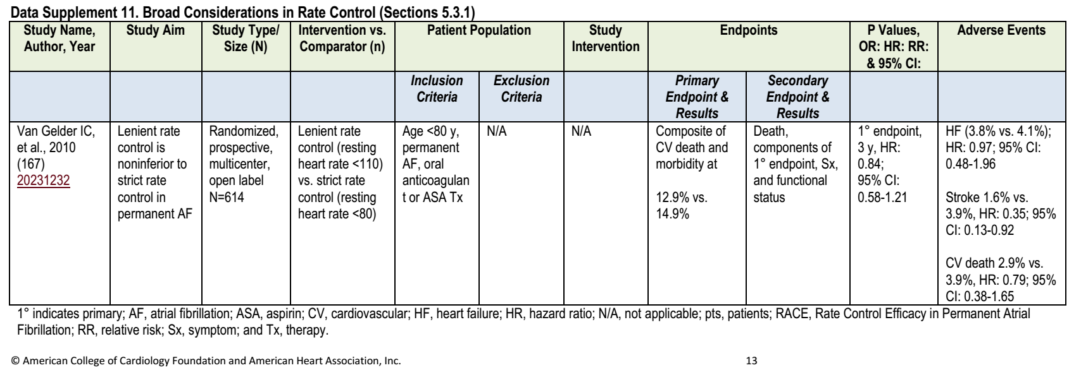
Tekstiline kokkuvõte tõendusest koos viidetega
Background  Rate control is often the therapy of choice for atrial fibrillation. Guidelines recommend strict rate control, but this is not based on clinical evidence.  We hypothesized that lenient rate control is not inferior to strict rate control for preventing cardiovascular morbidity and mortality in patients with permanent atrial fibrillation.  Methods  We randomly assigned 614 patients with permanent atrial fibrillation to undergo a lenient rate-control strategy (resting heart rate <110 beats per minute) or a strict ratecontrol strategy (resting heart rate <80 beats per minute and heart rate during moderate exercise <110 beats per minute).  The primary outcome was a composite of death from cardiovascular causes, hospitalization for heart failure, and stroke, systemic  embolism, bleeding, and life-threatening arrhythmic events. The duration of followup was at least 2 years, with a maximum of 3 years.  Results  The estimated cumulative incidence of the primary outcome at 3 years was 12.9% in the lenient-control group and 14.9% in the strict-control group, with an absolute difference with respect to the lenient-control group of -2.0 percentage points (90%  confidence interval, -7.6 to 3.5; P<0.001 for the pre-specified non-inferiority margin).  The frequencies of the components of the primary outcome were similar in the two groups. More patients in the lenient-control group met the heart-rate target or targets (304 [97.7%], vs. 203 [67.0%] in the strict-control group; P<0.001) with fewer total visits (75 [median, 0], vs. 684 [median, 2]; P<0.001).  The frequencies of symptoms and adverse events were similar in the two groups.  Conclusions  In patients with permanent atrial fibrillation, lenient rate control is as effective as strict rate control and is easier to achieve. | Van Gelder IC et al. Lenient vs strict rate control in patients with atrial fibrillation. N Engl J Med 2010;362:1363-  73.

OBJECTIVES:  The aim of this study was to investigate the influence of rate control on quality of life (QOL).  BACKGROUND:  The RACE II (Rate Control Efficacy in Permanent Atrial Fibrillation II) trial showed that lenient rate control is not inferior to strict rate control in terms of cardiovascular morbidity and mortality. The influence of stringency of rate control on QOL is unknown.  METHODS:  In RACE II, a total of 614 patients with permanent atrial fibrillation (AF) were randomized to lenient (resting heart rate [HR] <110 beats/min) or strict (resting HR <80 beats/min, HR during moderate exercise <110 beats/min) rate control. QOL was assessed in 437 patients using the Medical Outcomes Study 36-item Short-Form Health Survey (SF-36) questionnaire, AF severity scale, and Multidimensional Fatigue Inventory-20 (MFI-20) at baseline, 1 year, and end of study. QOL changes were related to patient characteristics.  RESULTS:  Median follow-up was 3 years. Mean age was 68 ± 8 years, and 66% were males. At the end of follow-up, all SF-36 subscales were comparable between both groups. The AF severity scale was similar at baseline and end of study. At baseline and at end of study there were no differences in the MFI-20 subscales between the 2 groups. Symptoms at baseline, younger age, and less severe underlying disease, rather than assigned therapy or heart rate, were associated with QOL improvements. Female sex and cardiovascular endpoints during the study were associated with worsening of QOL.  CONCLUSIONS:  Stringency of heart rate control does not influence QOL. Instead, symptoms, sex, age, and severity of the underlying disease influence QOL. | Groenveld HF et al. The effect of rate control on quality of life in patients with permanent atrial fibrillation: data from the RACE II (Rate Control Efficacy in Permanent Atrial Fibrillation II) study. J Am Coll Cardiol. 2011 Oct 18;58(17):1795-803. doi: 10.1016/j.jacc.2011.06.055.

